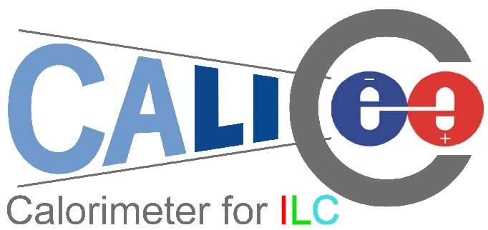

CERN-SPSC-2005-036
SPSC-P-328

Proposal for SPS beam time for the CALICE calorimeter prototypes

CALICE Collaboration

(CAlorimetry for the LInear Collider Experiment)

(submitted October 31st, 2005)

Spokesman: Jean-Claude Brient, Ecole Polytechnique, France
Testbeam contacts: Paul Dauncey, Imperial College London, UK
Felix Sefkow, DESY, Germany

- CALICE
The CALICE (CAlorimetry for a LInear Collider Experiment) collaboration consists of 190 physicists from 32 institutions, located in 9 countries worldwide. The goal is to develop and design a highly granular calorimeter for an experiment at the future international linear collider (ILC).
The physics program of the ILC requires the reconstruction of multi-jet final states, and the separation of W and Z bosons in their hadronic decay mode by means of the di-jet invariant mass. This translates into an unprecedented jet energy resolution of about 30%/√E. In the particle flow approach (PFA), the overall detector performance is optimized by reconstructing each particle individually in the detector which can measure it best. This requires excellent spatial resolution of the calorimeters to separate out particles close together in hadronic jets and hence requires very high granularity and compactness.
The CALICE collaboration is considering all parts of the calorimeter in an integrated study. This involves the design of a sampling electromagnetic calorimeter (ECAL) using silicon as the active detector and tungsten as the absorber. For the hadron calorimeter (HCAL), steel is used as the absorber and two active detector options are being considered: a gas-based (GEM or RPC) option with very high granularity and digital readout (DHCAL), and a scintillator-based option with analogue readout via novel photo-detectors and fine (but somewhat more moderate) granularity (AHCAL).
Event reconstruction using PFA algorithms requires knowledge of the detailed structure of hadronic (and electromagnetic) showers which cannot be inferred from existing calorimeter data. Current simulation models are affected by large uncertainties associated with the hadronic shower development, as illustrated in Figure 1.1. The calorimeter design has a strong impact on the overall ILC detector architecture and cost but the optimization of such a detector cannot be done reliably with such uncertainties. Testbeam measurements with prototypes are therefore a vital part of the CALICE program to allow accurate tuning of the simulation for these studies.
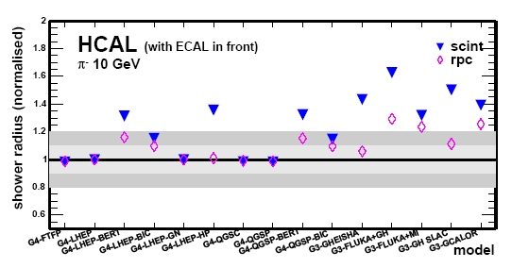Figure 1.1: Normalized shower radius in a hadron calorimeter as predicted by different hadron shower models.

The major goals of the collaboration are twofold: firstly, to demonstrate in principle the viability of the chosen technologies and to gain experience in their use in a realistic environment for further optimization, and secondly, to test and validate the simulation models using real data, which will also be essential for the development of PFA reconstruction algorithms. For this purpose, the collection of fairly large test beam data samples (totalling of the order of 10⁸ events) is necessary.
The collaboration is constructing and commissioning ECAL and AHCAL “physics prototypes”, together with a tail catcher, which are expected to be ready for test beam exposure in summer 2006. DHCAL prototypes will only become available in 2007 and so will not be considered further here. This proposal requests beam time at the SPS for stand-alone ECAL and AHCAL runs, followed by combined ECAL + AHCAL + tail catcher runs.

- The detector prototypes

2.1. The electromagnetic calorimeter (ECAL)
The CALICE prototype ECAL is a sampling calorimeter consisting of 30 active layers of silicon diode pad detectors sandwiched between tungsten sheets. The tungsten thickness varies from 1.4mm at the front to 4.2mm at the rear, with a total thickness of 24X₀. The silicon pads are 1×1cm² and each layer contains an 18×18 pad array, giving a total of almost 10,000 channels in an active volume approximating a cube of 20 cm on each side.
The on-detector electronics is based around a custom-designed ASIC which contains a pre-amplifier, shaper and sample-and-hold for each of 18 channels followed by multiplexed analogue readout. The ASICs and silicon wafers for each layer are mounted directly onto a PCB and these are inserted into spaces in the tungsten-carbon fibre mechanical structure to assemble the complete calorimeter; see Figure 2.1. The whole calorimeter is read out via 9U custom-designed VME boards, which digitise and buffer the data during a spill for subsequent readout after the spill.
A preliminary engineering run with 14 of the 30 layers was performed in an electron test beam at DESY during 2005; see Figure 2.1. Around 2×10⁷ events were taken and analysis is in progress. Sufficient silicon wafers for the rest of the ECAL are being fabricated and the prototype is scheduled to be completed in early 2006.

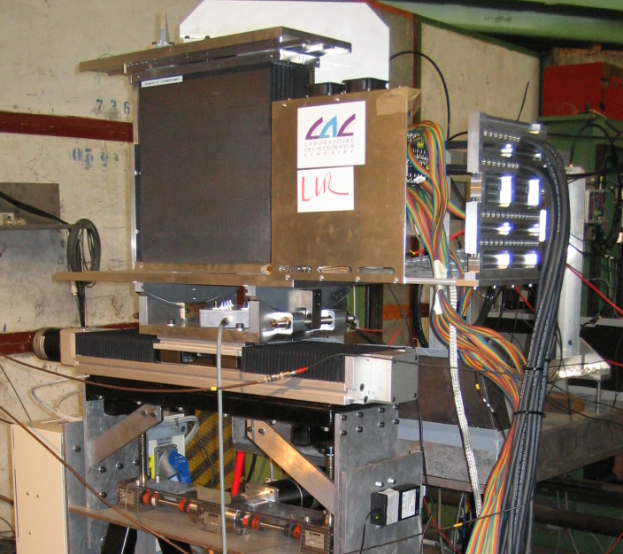
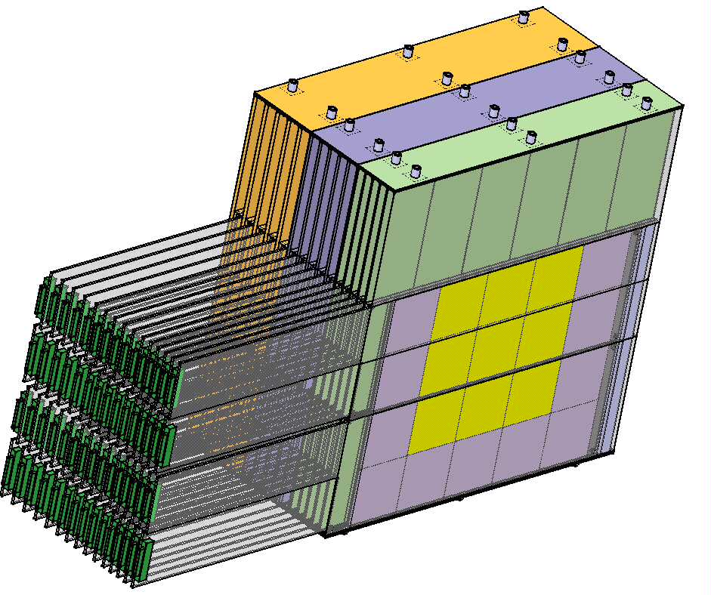Figure 2.1: Schematic view of the prototype (left), photography of the prototype at the DESY test beam (right).

2.2. The analogue hadronic calorimeter (AHCAL)

The AHCAL prototype is a scintillator steel sampling calorimeter of about one cubic meter size. 38 layers of 16 mm thick steel plates are arranged in a flexible stack and interleaved with 38 steel cassettes as active modules, each containing 216 scintillator tiles. The tiles are 5 mm thick and have 3x3 cm² transverse size in a central core of the detector, which is surrounded by larger tiles; see Figure 2.2. Each tile is read out individually via a wavelength shifting (WLS) fibre coupled to a silicon photomultiplier (SiPM) mounted on the tile. The SiPM is a novel multi-pixel avalanche photodiode operated in Geiger mode and provides a gain of more than10⁵.
The front end electronics is mounted on one side of the cassettes (see Figure 2.2). It is based on an 18 channel ASIC which is a modified version of the one used for the ECAL, so the same DAQ system - with 6 additional VME boards - is being used for ASIC control and readout. The modules are also equipped with a versatile LED system for calibration and monitoring.
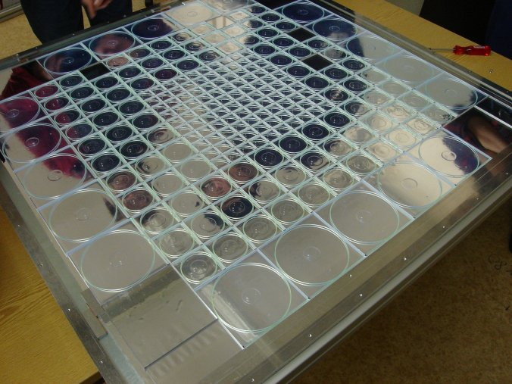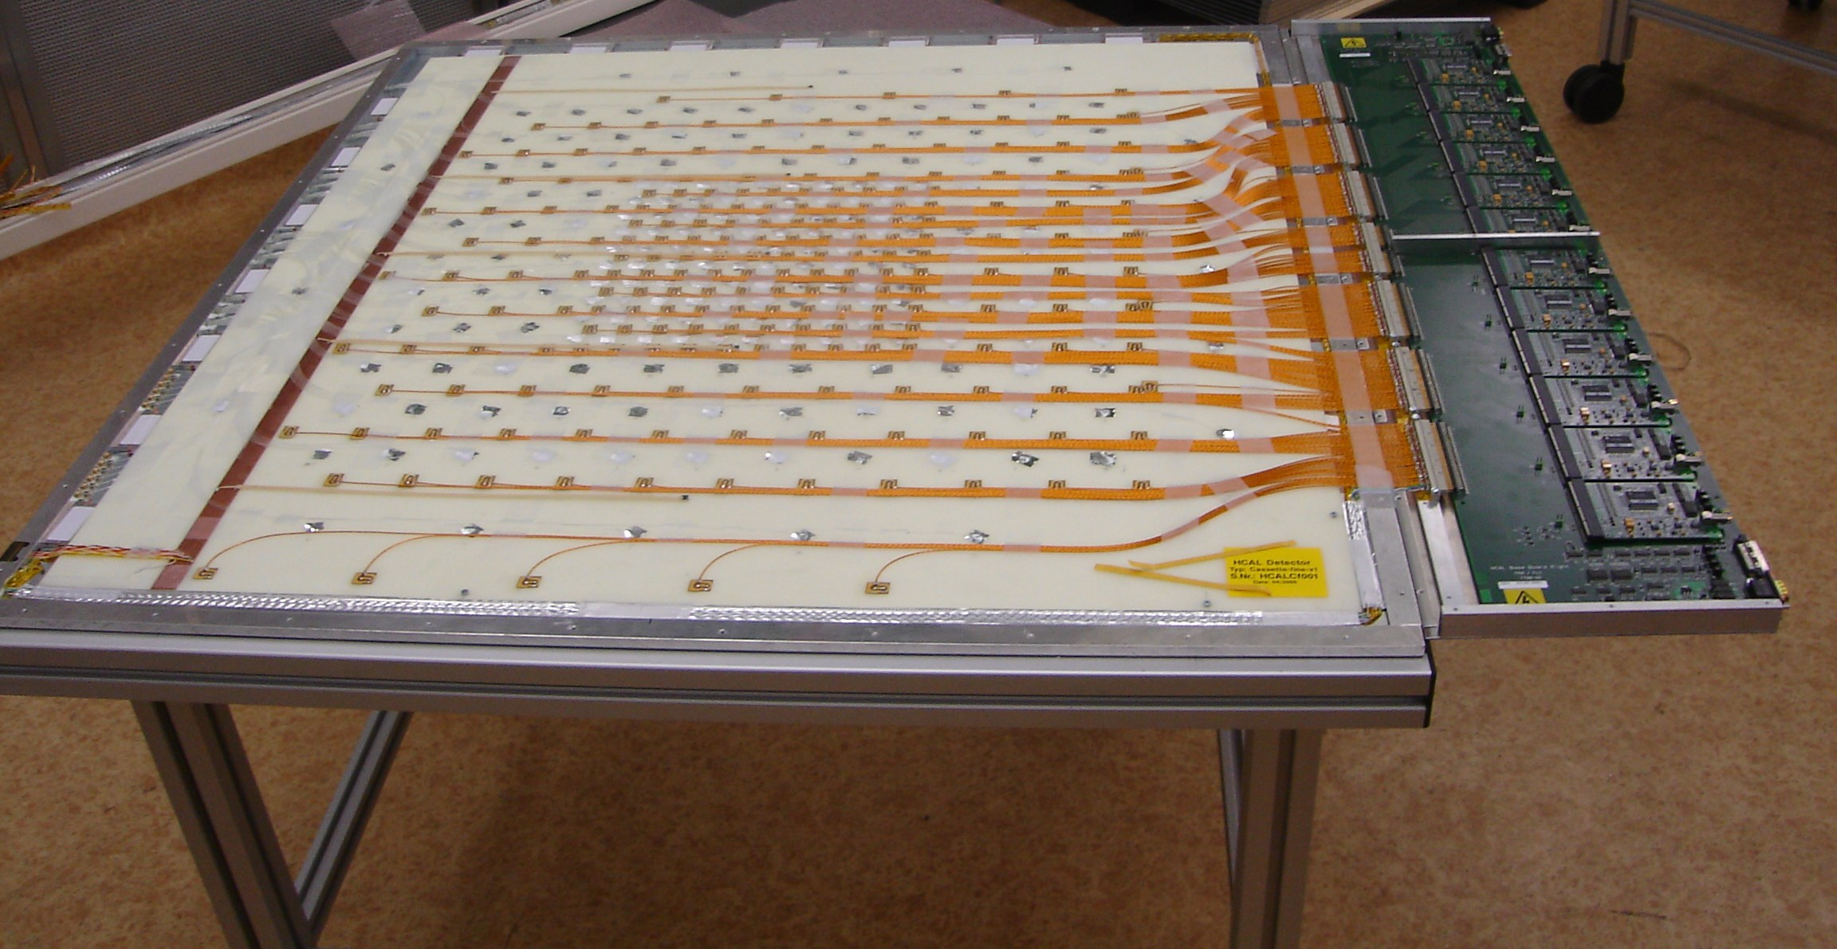
Figure 2.2: Scintillator tile layer (left), complete module with front end electronics (right).
.
The stack, the complete readout electronics and six active modules have been produced. The first cassette with its final electronics has been commissioned in the DESY testbeam this summer. Completion of module assembly and construction of the movable stage are foreseen for the first half of 2006. Figure 2.3 shows the stack on the stage in a configuration set up for inclined beam incidence; the design ensures that the beam still passes through the central high granularity core in all layers for angles up to 35º.

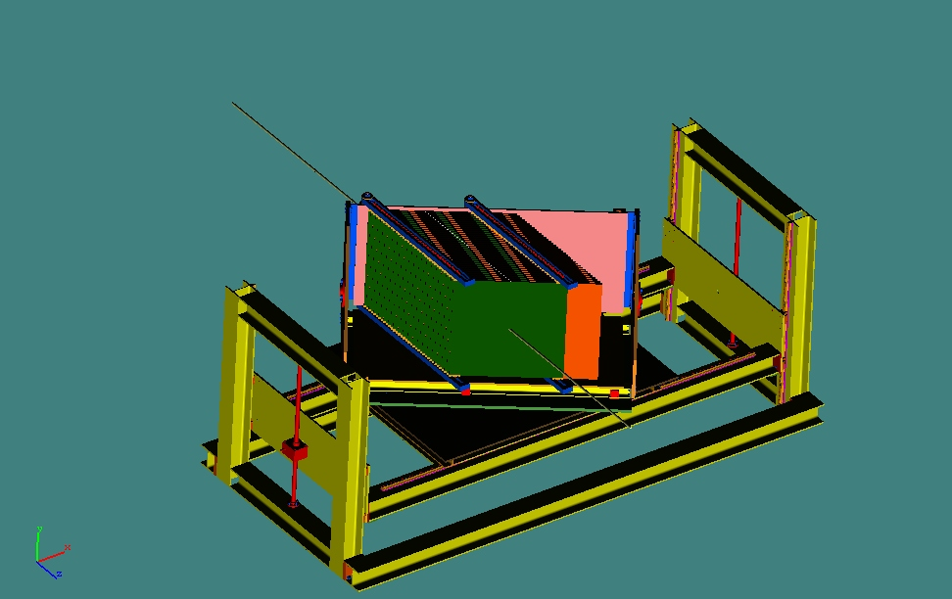

Figure 2.3: HCAL absorber stack on its movable stage (left), tail catcher stack and table (right).

2.3. The tail catcher (TC)

The tail catcher (see Figure 2.3) is a prototype of a muon detector system for an ILC detector and is also able to provide a measure of rear leakage of hadronic showers from the AHCAL. It consists of a scintillator-steel structure, with 16 active layers of 5 cm wide scintillator strips sandwiched between steel layers of thicknesses varying from 2 to 10 cm. The scintillator is read out using WLS fibres coupled directly to SiPMs, in a similar way to the AHCAL. It also shares common on- and off-detector readout electronics with the AHCAL and the readout of the two detectors will be integrated through a single VME crate.

2.4. DAQ, trigger and event rates
The VME readout boards are common to all three detectors, making the online system reasonably uniform. The boards can transfer, digitise and buffer data from the on-detector electronics at event rates up to 3 kHz. Each board has an 8 MByte memory which allows up to 2000 events to be buffered during a spill. Following this, the data are read out to the online system at a rate around 100 Hz.
No zero suppression is performed online to allow detailed studies of pedestal and noise stability from the data taken. This results in an event size of around 50 kBytes and hence a rate to disk of around 5 MBytes/s. It is planned to transfer all data to dCache at DESY for subsequent Grid distribution and analysis. However, the online system has a 3TByte local disk array to provide sufficient buffering for up to a week of data-taking, if necessary due to network bottlenecks. The requested run at CERN would aim to acquire around 10⁸ events, which gives a total data sample of around 5TBytes.

- Testbeam request

3.1. General considerations

Mean single particle energies in hadronic jets in ILC events are typically 6 to 12 GeV, but the spectra extend to 100 GeV and beyond. The test beams should thus cover an energy range starting in the few GeV regime and reach up to 100 GeV at least. Electrons and hadrons are obviously needed; muons are necessary in addition for calorimeter tracking studies and calibration. The range of particle incidence angles at the ILC is also large and suggests a flexible test set-up allowing for wide angular scans is needed at the test beam.
The beam must be well defined: the energy spread should stay within 1-2%, particle identification devices should allow particle selection with reasonably high purity, and tracking devices must define the impact for single events to better than 1 mm precision.
In order to estimate the sensitivities required to validate simulations, Monte Carlo studies using different hadron shower codes have been performed. Considerable differences are observed in both the ECAL and HCAL, and they vary with energy, particle type, and active detector material. Thus both pions and (anti-) protons need to be studied, and the various proposed HCAL technologies must all be tested.
The number of different detector, particle type, energy and angular configurations to be tested is of order 10². Studies indicate detailed comparisons of data to known differences between simulation models would require around 10⁵ clean events for each of these configurations. This translates into a data sample of 10⁶ events per configuration being needed, not only to allow tight event selection to get rid of badly reconstructed or polluted events, but also to analyze the hadron shower data as a function of observables which cannot be pre-configured, such as the electromagnetic energy fraction, the number of hadronic interaction vertices, or the longitudinal and lateral containment. Such studies are needed for the optimization of both the single particle energy reconstruction using weighting methods, as well as for particle flow algorithm development.
The aim is therefore to collect a total data sample of around 10⁸ triggers. With a data taking rate of 100 Hz, this would require less than two weeks if running continuously, which is of course not possible in practise. Changing the beam and detector setup for the various configurations needed, as well as general beam down time, will contribute to inefficiencies. A conservative estimate of an overall 25% running efficiency therefore results in a requested period in the CERN beam line totalling eight weeks.

3.2. Experimental setup at the SPS

Mechanical integration: From the above energy range considerations we conclude that the beam areas H2 and H8 which also offer low energy tertiary beams would be best suited for our programme. The H6 beam line would also fit our basic needs. For part of the ECAL standalone runs, the highest possible electron beam quality would be desirable.
The space requirements of the ECAL alone are not considered problematic. For the AHCAL and the tail catcher, possible integration scenarios have been tentatively studied through cooperation of DESY and CERN engineering staff. As an example the complete detector configuration positioned in the experimental area H2A is shown in Figure 3.1. A similar study revealed that installation in the area H6B is also possible in principle. The area H8C would be a further promising candidate; space constraints are here considered to be less critical.
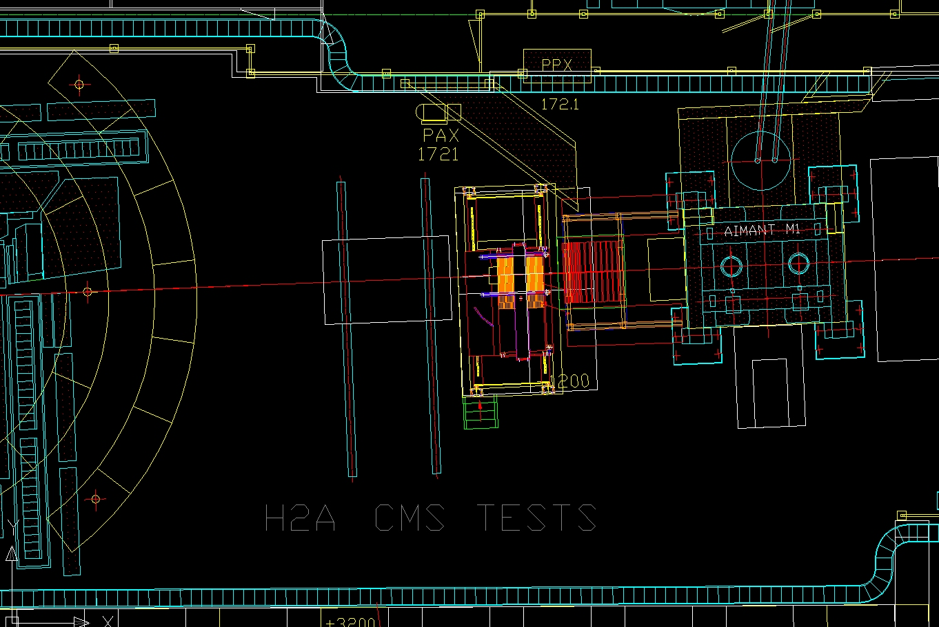
Figure 3.1: Example of integration of the ECAL, AHCAL and tail catcher in beam area H2A.

Installation: The time needed for assembly and cabling of the AHCAL prototype with its movable table in the experimental area is conservatively estimated to be 10 working days. If this is incompatible with the SPS programme, it would be possible to modify the structure such that it can be moved by crane as a whole; assembly and cabling could then proceed in a staging area where it does not interfere with other test beam users. Installation of the ECAL takes one day, as already exercised in the DESY test beam. The tail catcher present design already allows it to be moved as a whole by crane.
Instrumentation: We request the use of CERN delay wire chambers (DWC) as tracking devices for the event-by-event determination of the particle impact trajectory. Two stations with horizontal and vertical coordinate measurements are the minimum required, although a third station would be highly desirable to add redundancy.
For electron-hadron separation in the momentum range under consideration, we would like to use a Cherenkov counter. A second counter for proton separation would be highly desirable.
The group will provide their own trigger devices (scintillation counters).
Further infrastructure requirements: We are asking CERN for the provision of network access, electrical power, a gas supply for the beam instrumentation devices (DWC, Cherenkovs), technical support to move and install the detectors and some expertise to help and support the beam line operation. We need a temporary counting room and some office space. Access to the CASTOR system for temporary mass storage would be beneficial.

3.3. Test beam programme

The programme would begin with independent installation and commissioning of the ECAL and of the AHCAL together with the tail catcher. Since all systems use similar front end electronics and the same trigger, DAQ and software, the teams can support each other effectively.
Although the ECAL will have been calibrated with cosmics before being moved to CERN, the AHCAL will require calibration with muons at the beam area. Several million muon events distributed over the full front face (1 m²) need to be collected. Therefore, ideally, the AHCAL electronics commissioning would be followed by a period of parasitic operation in a muon area with free access, of about two week duration.
The actual testbeam programme would start with standalone runs. ECAL-only runs with electrons, and AHCAL-only runs with both electrons and hadrons, are needed. These data are used for systematics studies and to understand the detector response and resolution, using events with precisely known incident energy. These are also essential for the optimization of energy weighting procedures. These data for the two detectors can be taken in parallel or sequentially. Four weeks of beam time are requested altogether for this first period, although this does not have to be contiguous. Ideally, following successful standalone data collection, in the last week a combined ECAL + AHCAL + tail catcher run would be taken. Figure 3.2 shows a simulated event in all three detectors.
We are requesting a second run period of four weeks towards the end of the 2006 SPC testbeam operation, with an intermediate period of around four weeks between the two run periods for analysis and optimization of detector and beam settings. In the second period, the emphasis would be on combined runs, although some further standalone data taking may be necessary, too. The program should include a test of the ECAL electronics with ASICs embedded in the active detector structure using highest possible electron energies.
In order to optimally cover the energy range relevant for our studies, we are asking for one of the two beam periods to have the beam set up in tertiary low energy mode. We would prefer this to be in the second period.
.
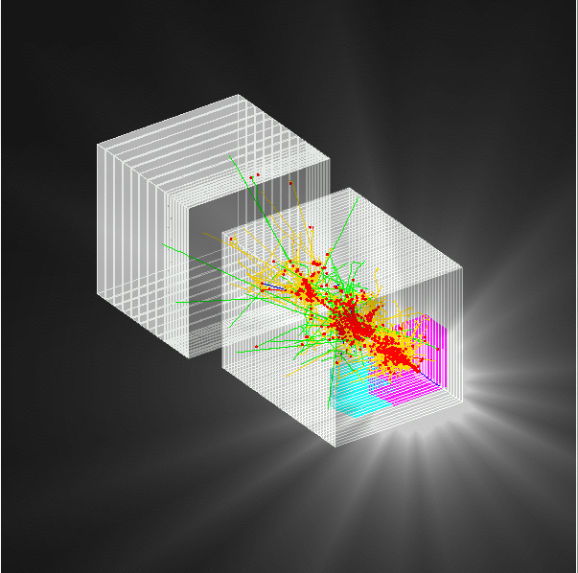

Figure 3.2 A simulated hadron event in the combined testbeam setup. The ECAL is shown in purple, the AHCAL in white in the centre and the tail catcher in white at the rear.

