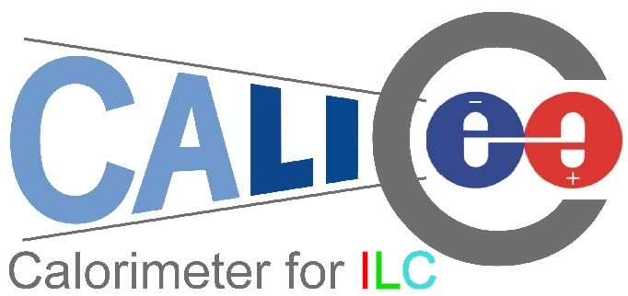

CERN-SPSC-2007-XX
SPSC-P-YY

Proposal for 2007 SPS beam time for the CALICE calorimeter prototypes

CALICE Collaboration

(CAlorimetry for the LInear Collider Experiment)

(submitted January 31st, 2007)

Spokesperson: Jean-Claude Brient, Ecole Polytechnique, France
Testbeam contacts: Paul Dauncey, Imperial College London, UK
Felix Sefkow, DESY, Germany

- CALICE
The CALICE (CAlorimetry for a LInear Collider Experiment) collaboration consists of 190 physicists from 38 institutions, located in 13 countries worldwide. The goal is to develop and design a highly granular calorimeter for an experiment at the future international linear collider (ILC).
The physics program of the ILC requires the reconstruction of multi-jet final states, and the separation of W and Z bosons in their hadronic decay mode by means of the di-jet invariant mass. This translates into an unprecedented jet energy resolution of about 30%/√E. In the particle flow approach (PFA), the overall detector performance is optimized by reconstructing each particle individually in the detector which can measure it best. This requires excellent spatial resolution of the calorimeters to separate out particles close together in hadronic jets and hence requires very high granularity and compactness.
The CALICE collaboration is considering all parts of the calorimeter in an integrated study. This involves the design of a sampling electromagnetic calorimeter (ECAL) using silicon as the active detector and tungsten as the absorber. For the hadron calorimeter (HCAL), steel is used as the absorber and two active detector options are being considered: a gas-based (GEM or RPC) option with very high granularity and digital readout (DHCAL), and a scintillator-based option with analogue readout via novel photo-detectors and fine (but somewhat more moderate) granularity (AHCAL).
Event reconstruction using PFA algorithms requires knowledge of the detailed structure of hadronic (and electromagnetic) showers which cannot be inferred from existing calorimeter data. Current simulation models are affected by large uncertainties associated with the hadronic shower development. The calorimeter design has a strong impact on the overall ILC detector architecture and cost but the optimization of such a detector cannot be done reliably with such uncertainties. Testbeam measurements with prototypes are therefore a vital part of the CALICE program to allow accurate tuning of the simulation for these studies.
The major goals of the collaboration are twofold: firstly, to demonstrate in principle the viability of the chosen technologies and to gain experience in their use in a realistic environment for further optimization, and secondly, to test and validate the simulation models using real data, which will also be essential for the development of PFA reconstruction algorithms. For this purpose, the collection of fairly large test beam data samples (totalling of the order of 10⁸ events) is necessary.
The collaboration is constructing and commissioning ECAL and AHCAL “physics prototypes”, together with a tail catcher. Initial beam data were taken with these ~2/3 complete at CERN in 2006. The fully completed detectors are expected to be ready for test beam exposure in summer 2007. DHCAL prototypes will only become available in 2008 and so will not be considered further here. This proposal requests beam time at the SPS for runs of the completed calorimetry systems in 2007.

- The detector prototypes

2.1. The electromagnetic calorimeter (ECAL)
The CALICE prototype ECAL is a sampling calorimeter consisting of 30 active layers of silicon diode pad detectors sandwiched between tungsten sheets. The tungsten thickness varies from 1.4mm at the front to 4.2mm at the rear, with a total thickness of 24X₀. The silicon pads are 1×1cm² and each layer contains an 18×18 pad array, giving a total of almost 10,000 channels in an active volume approximating a cube of 20 cm on each side.
The on-detector electronics is based around a custom-designed ASIC which contains a pre-amplifier, shaper and sample-and-hold for each of 18 channels followed by multiplexed analogue readout. The ASICs and silicon wafers for each layer are mounted directly onto a PCB and these are inserted into spaces in the tungsten-carbon fibre mechanical structure to assemble the complete calorimeter; see Figure 2.1. The whole calorimeter is read out via 9U custom-designed VME boards, which digitise and buffer the data during a spill for subsequent readout after the spill.
The beam run at CERN in 2006 had only six of the nine silicon wafers installed for each of the 30 layers. Hence the full depth of the calorimeter was available but it had limited lateral coverage, particularly for hadronic showers. Sufficient silicon wafers for the rest of the ECAL are being fabricated and tested and the prototype is scheduled to be completed in early 2007.

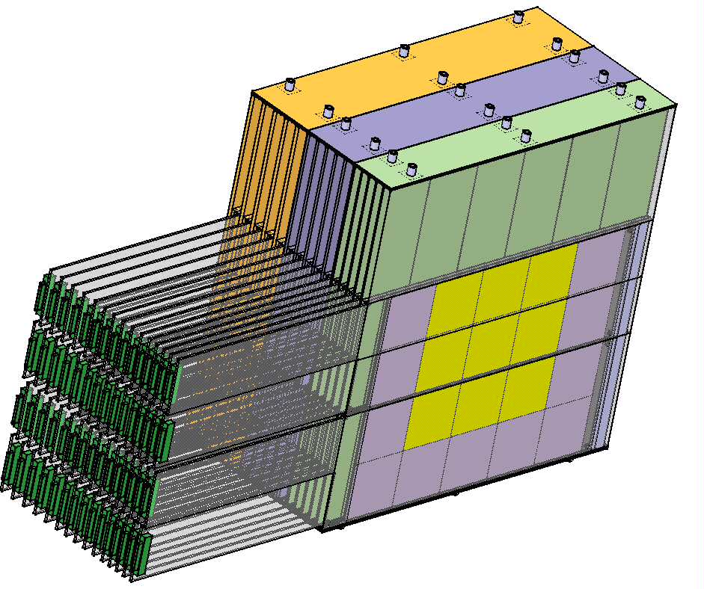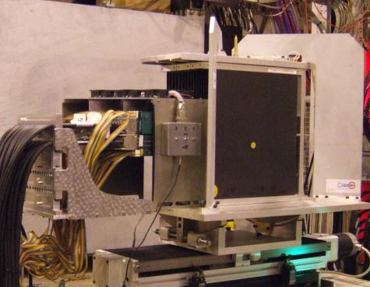Figure 2.1: Schematic view of the prototype (left), photograph of the prototype at the CERN test beam (right).

2.2. The analogue hadronic calorimeter (AHCAL)

The AHCAL prototype is a scintillator-steel sampling calorimeter of about one cubic meter size. 38 layers of 16 mm thick steel plates are arranged in a flexible stack and interleaved with 38 steel cassettes as active modules, each containing 216 scintillator tiles. The tiles are 5 mm thick and have a 3x3 cm² transverse size in the central core of the detector, which is surrounded by larger tiles; see Figure 2.2. Each tile is read out individually via a wavelength shifting (WLS) fibre coupled to a silicon photomultiplier (SiPM) mounted on the tile. The SiPM is a novel multi-pixel avalanche photodiode operated in Geiger mode and provides a gain of more than10⁵.
The front end electronics is mounted on one side of the cassettes (see Figure 2.2). It is based on an 18 channel ASIC which is a modified version of the one used for the ECAL, so the same DAQ system - with 6 additional VME boards - is being used for ASIC control and readout. The modules are also equipped with a versatile LED system for calibration and monitoring.
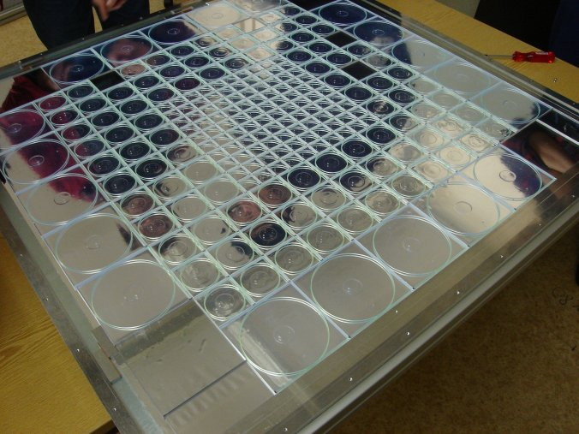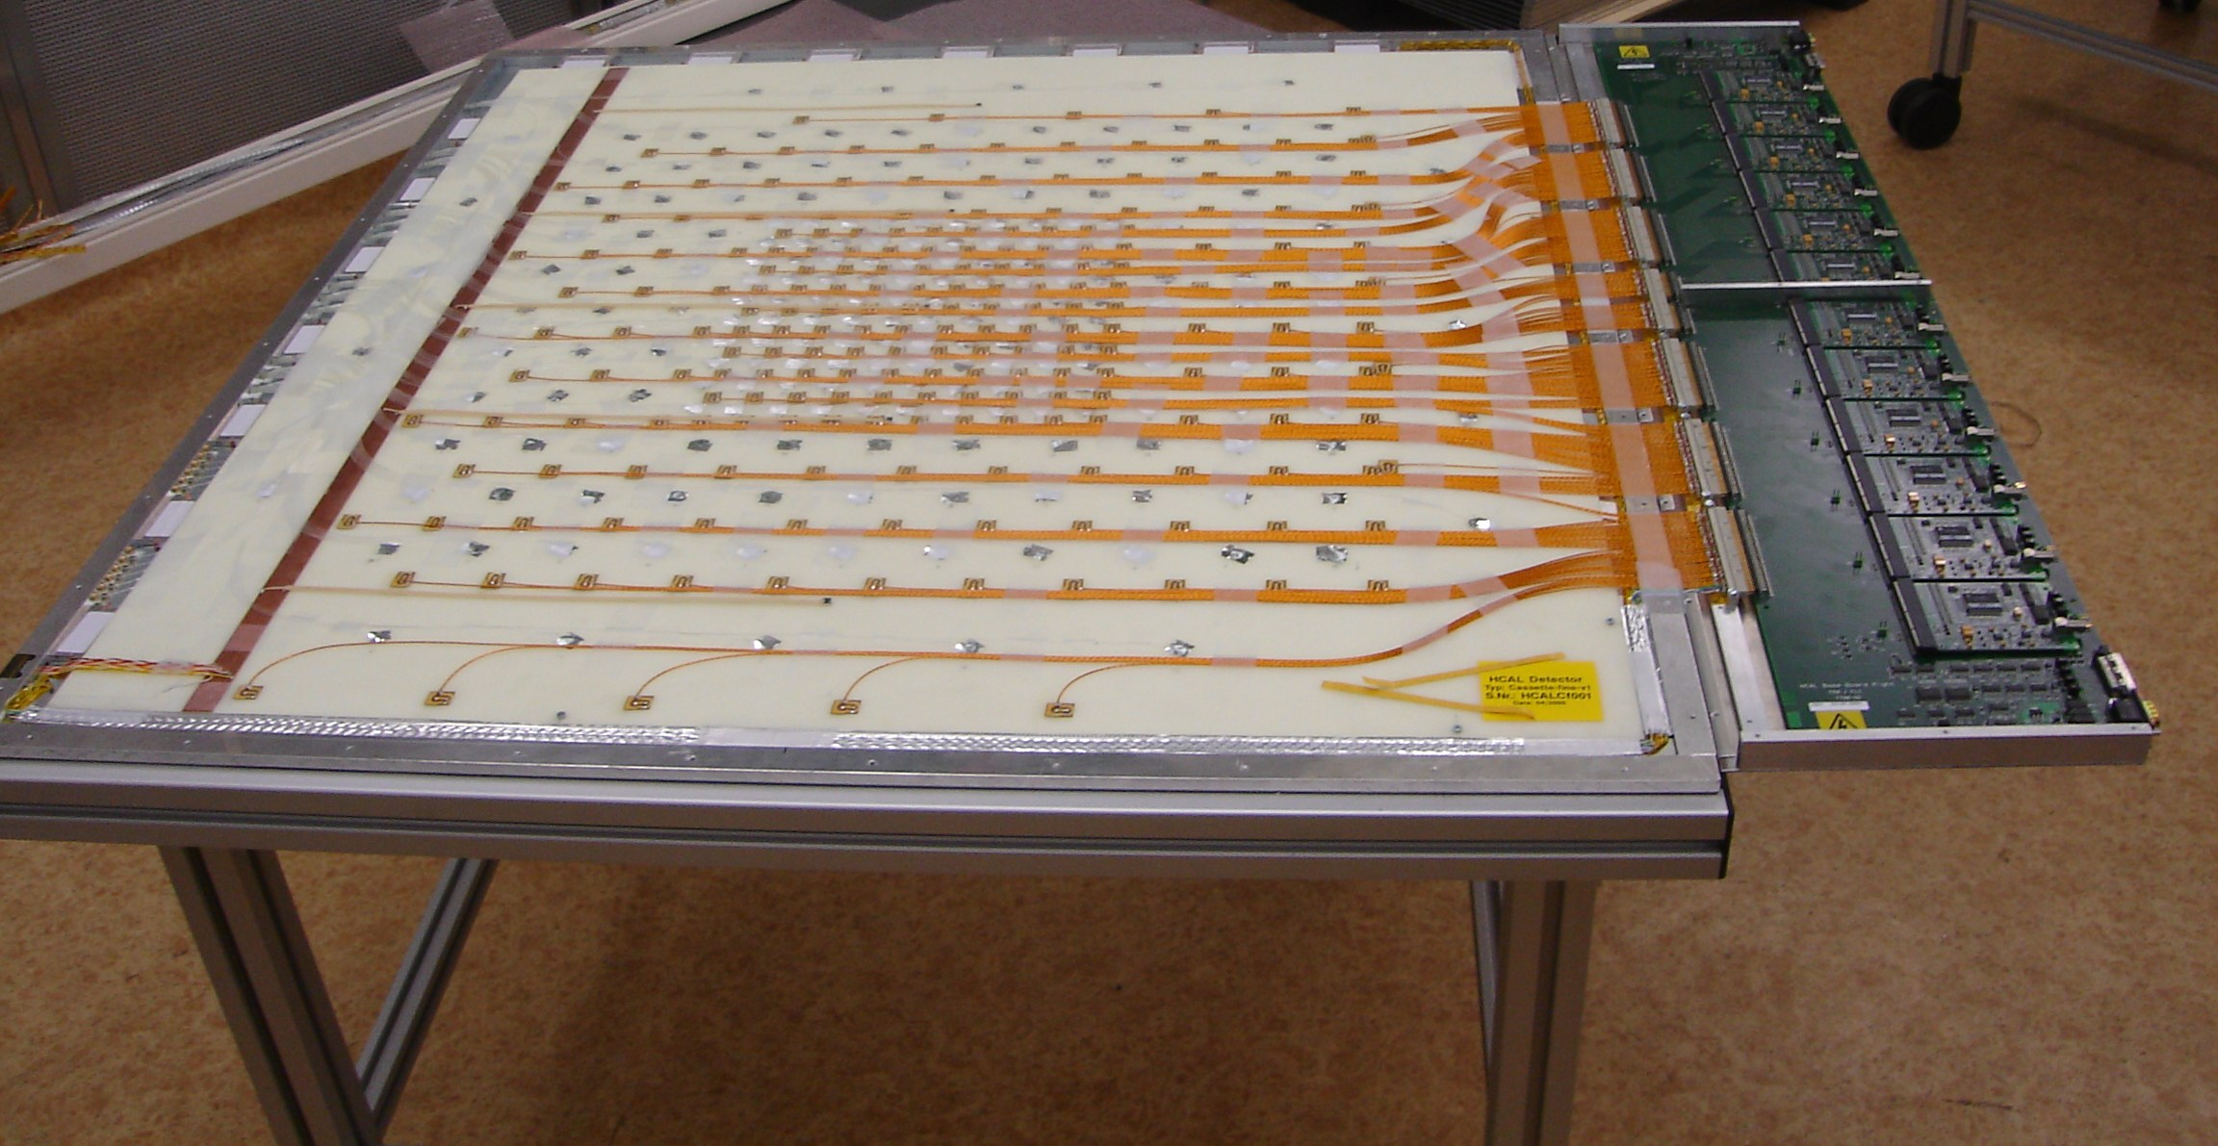
Figure 2.2: Scintillator tile layer (left), complete module with front end electronics (right).
.
A total of 23 of the 38 active modules were completed for the CERN beam tests in 2007 and these were arranged within the full absorber thickness to sample showers over the complete depth, albeit with reduced granularity in the rear of the calorimeter. Completion of the remaining modules is foreseen for early 2007. A movable stage to allow the complete HCAL to be translated and rotated with respect to the beam has been constructed and will be brought to CERN for the tests this summer. This is currently under test at DESY; Figure 2.3 shows the stack on the stage in a configuration set up for inclined beam incidence. The design ensures that the beam still passes through the central high granularity core in all layers for angles up to 35º.

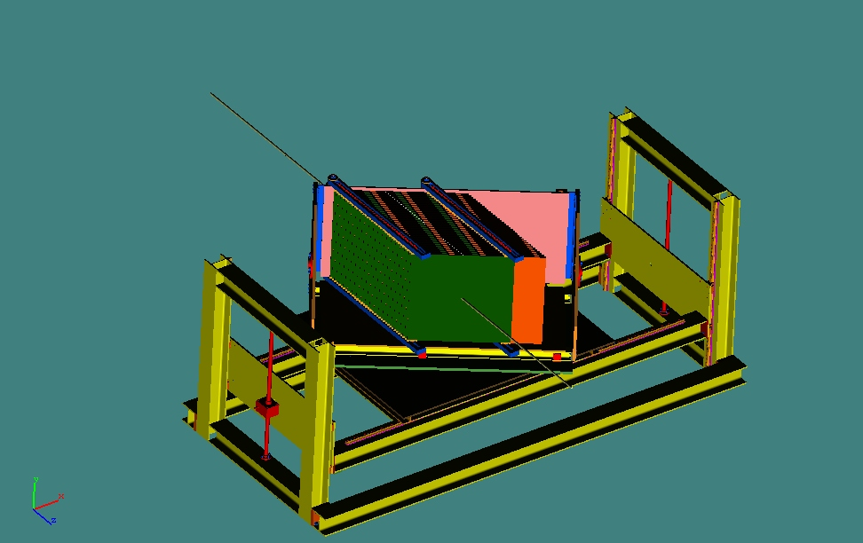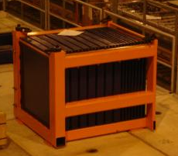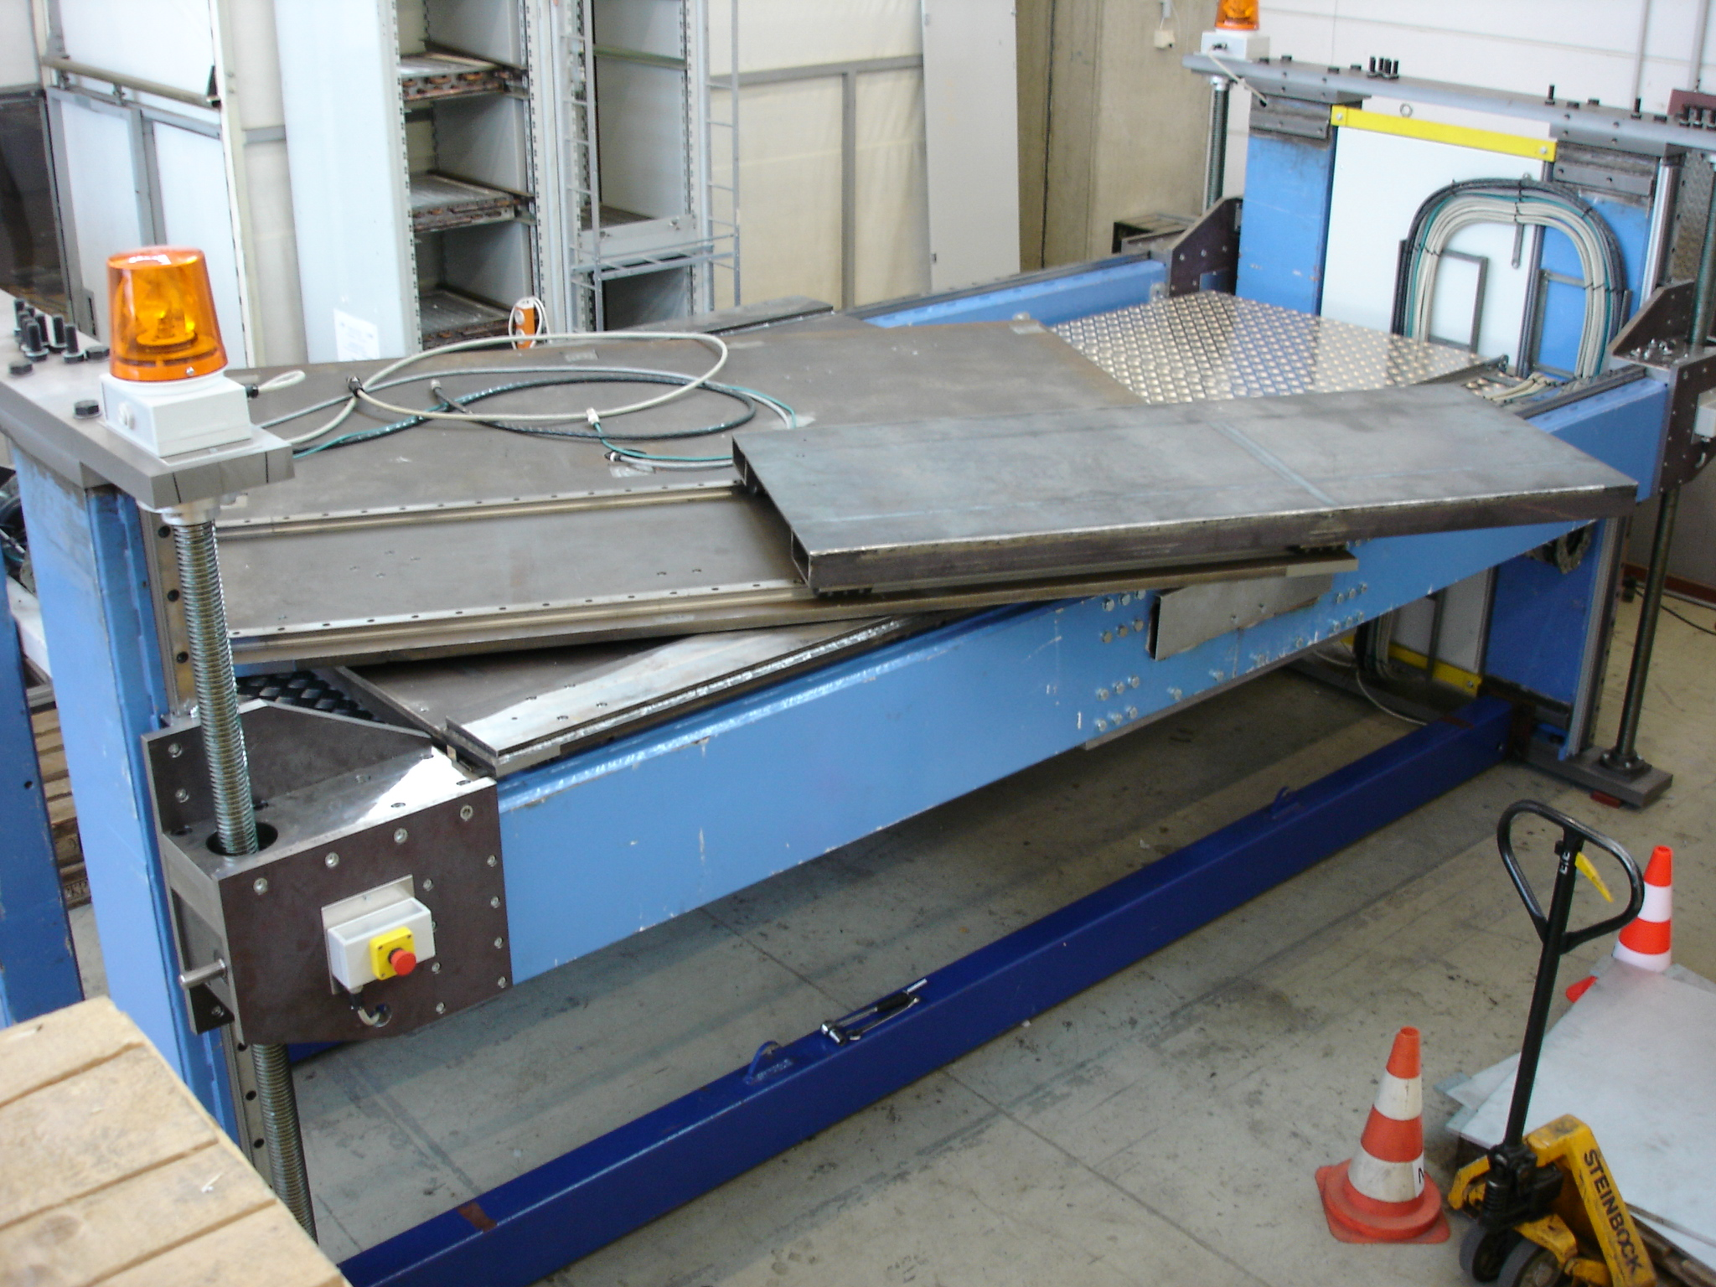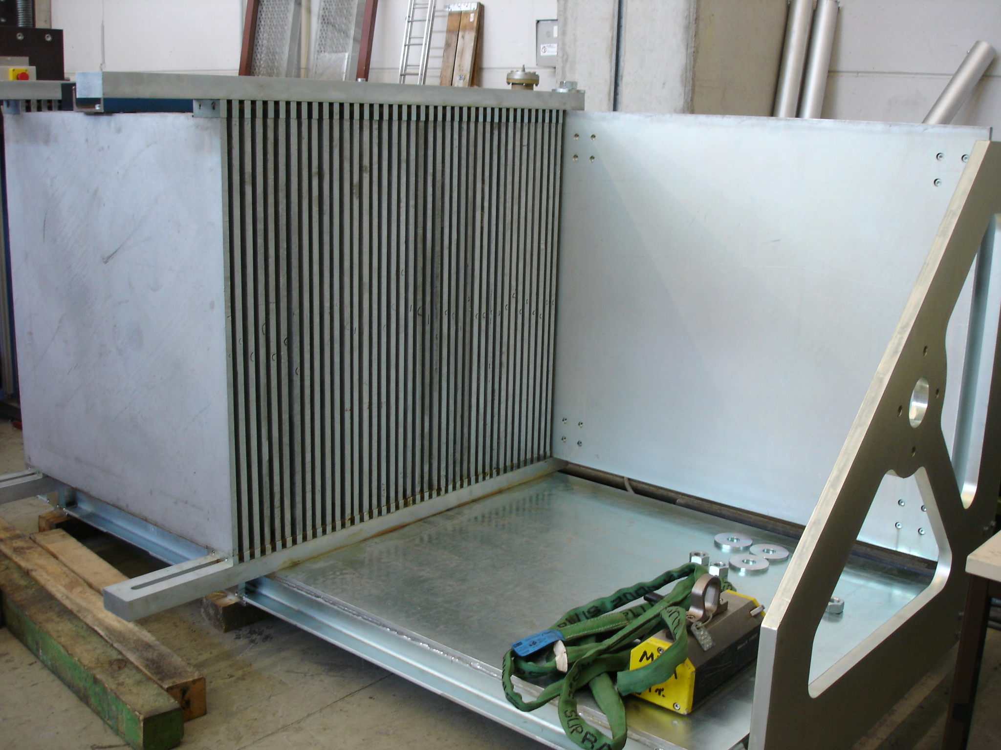

Figure 2.3: HCAL absorber stack on its movable stage (top left), stage (top right) and absorber stack (bottom left); tail catcher stack at CERN (right).

2.3. The tail catcher (TC)

The tail catcher (see Figure 2.3) is a prototype of a muon detector system for an ILC detector and is also able to provide a measure of rear leakage of hadronic showers from the AHCAL. It consists of a scintillator-steel structure, with 16 active layers of 5 cm wide scintillator strips sandwiched between steel layers of thicknesses varying from 2 to 10 cm. The scintillator is read out using WLS fibres coupled directly to SiPMs, in a similar way to the AHCAL.
It also shares common on- and off-detector readout electronics with the AHCAL and the readout of the two detectors is integrated through a single VME crate. The tail catcher was already completed for the 2006 CERN runs and will be present for the 2007 data-taking period also.

2.4. DAQ, trigger and event rates
The VME readout boards are common to all three detectors, making the online system reasonably uniform. The boards can transfer, digitise and buffer data from the on-detector electronics at event rates up to 3 kHz. Each board has an 8 MByte memory which allows up to 2000 events to be buffered during a spill. Following this, the data are read out to the online system at a rate around 100 Hz. A readout rate of around 130Hz was achieved in 2006 due to the smaller system size, which is consistent with the expected performance. A total of ~60M beam events and ~90M muon calibration events were taken during 2006.
No zero suppression is performed online to allow detailed studies of pedestal and noise stability from the data taken. This results in an event size of around 50 kBytes and hence a rate to disk of around 5 MBytes/s. The online system has a 3TByte local disk array to provide sufficient buffering for up to a week of data-taking, if necessary due to network bottlenecks. However, all data are normally transferred immediately to dCache storage at DESY for subsequent Grid distribution and analysis. This system worked well during the data-taking in 2006 and a total of about 5 TBytes was sent to DESY in total. The requested 2007 run at CERN would aim to acquire around 100M beam events and a similar number of calibration events, which would give a total data sample of around 10TBytes.

- 2006 testbeam results
Altogether, the 2006 testbeam period was very fruitful for the collaboration. Thanks to the efficient support from the CERN staff, integration into the beam area went very smoothly, and the detector system was then operated with an up-time above 90%.
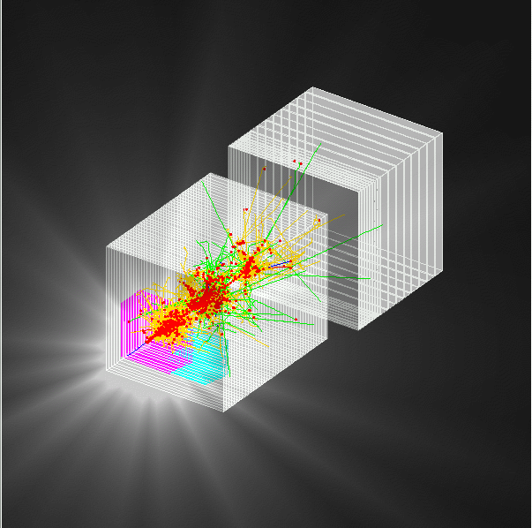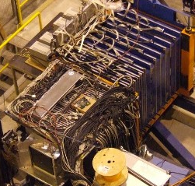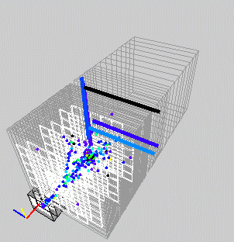

Figure 3.1: The experiment from concept to reality. A simulated hadron event in the combined testbeam setup (left). The installation of the three calorimeters at CERN (centre). One of the data events taken in 2006 (right).

3.1. Data taken
Overall, a total of ~60M beam events were taken during the two run periods for which there was beam. Figure 3.2 shows the integrated number acquired during these periods with a total of over 5M events/day being recorded when the beam was stable. These were taken with electron and pion beams over a wide range of energies. Data were taken with ECAL-only, AHCAL-only and combined runs. In addition, when other users in the H6 beamline were taking data, then parasitic muons for calibration purposes were recorded. This resulted in ~90M such events, with over 10M being taken on the best day.
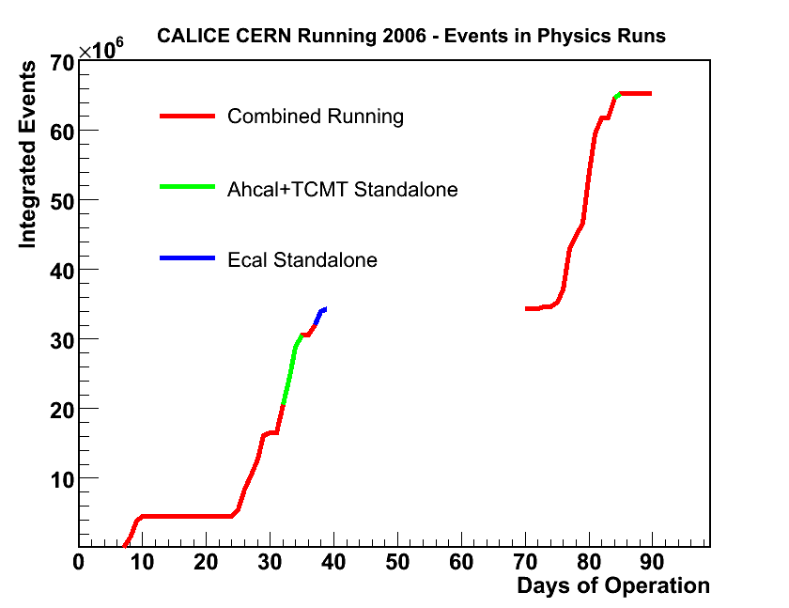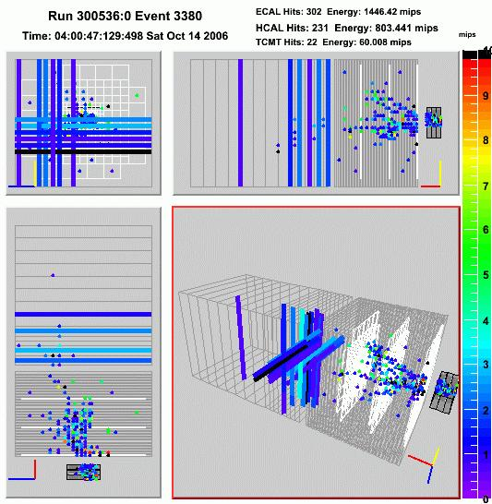

Figure 3.2: Integrated data sample as a function of time from the start of the second run period of 2006 (left). An example of a 40GeV pion shower in the ECAL, AHCAL and tail catcher as seen in the real-time event display (right).

3.2. A first look at the data
Final results from the 2006 data are not yet available although the analysis is in full swing. However, the results so far show the data to be of excellent quality. Figures 3.3 and 3.4 show some results illustrating the abilities of the calorimeters.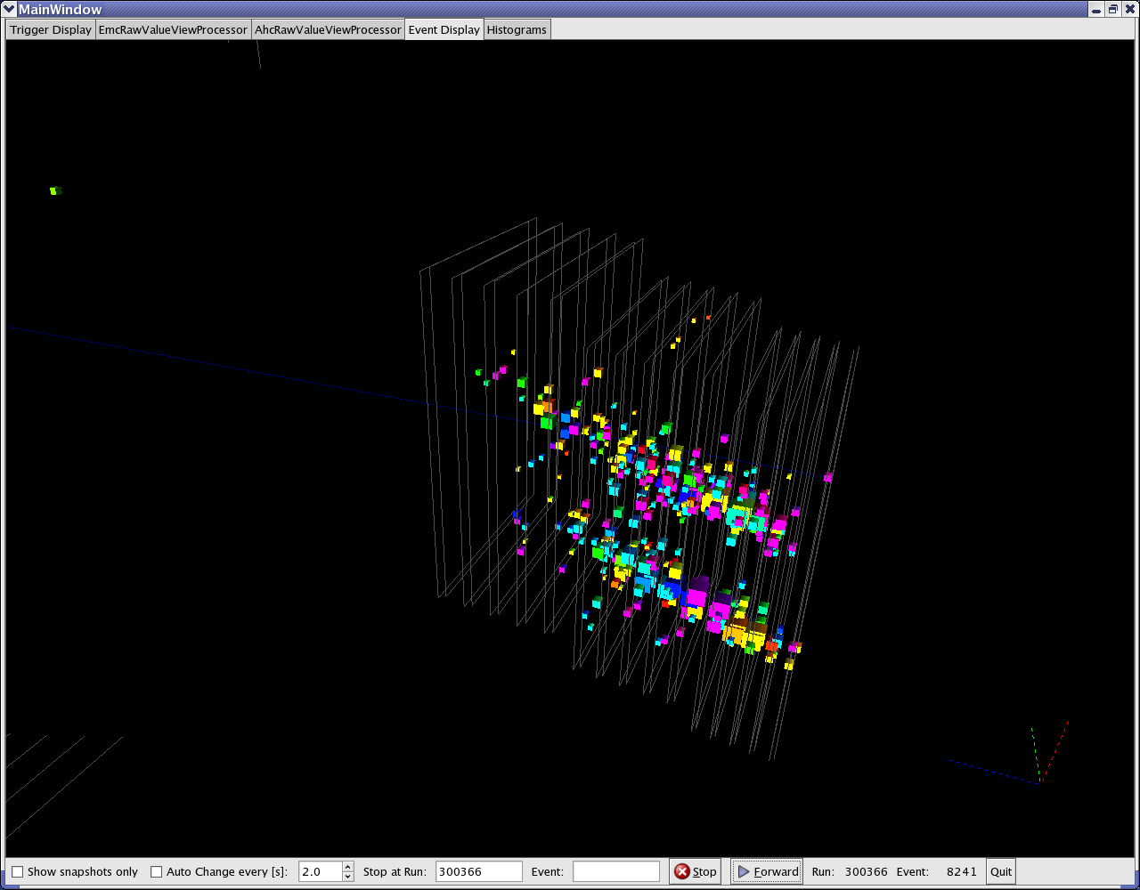

Figure 3.3: The total observed energy (in units of minimum ionising particles) in the ECAL for incidence electron energies between 10 and 50 GeV (left). A double electron event observed with an electron beam of 20 GeV energy showing the clean separation of the two EM showers (right).

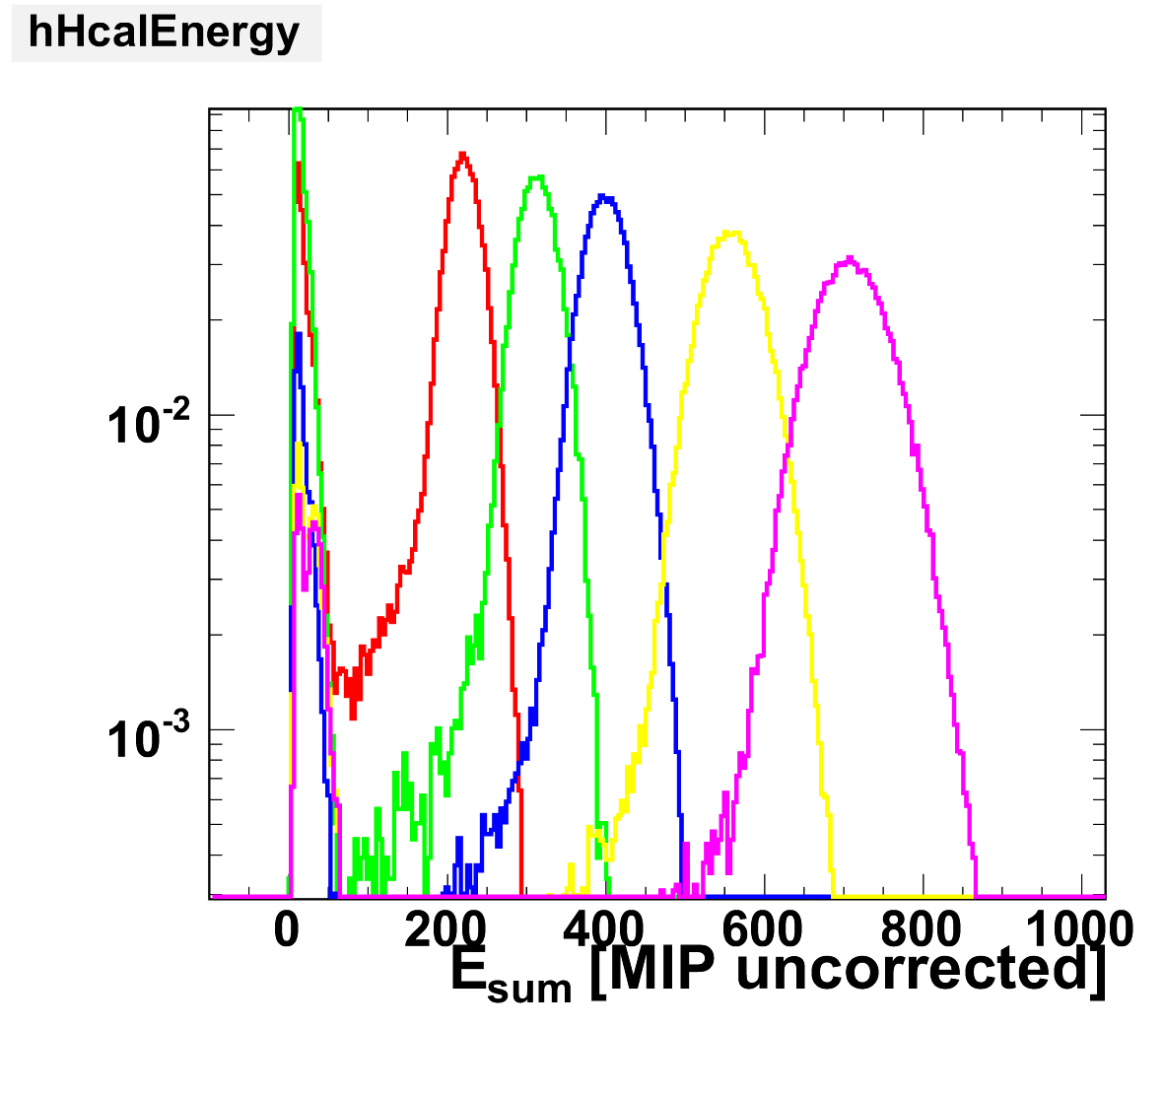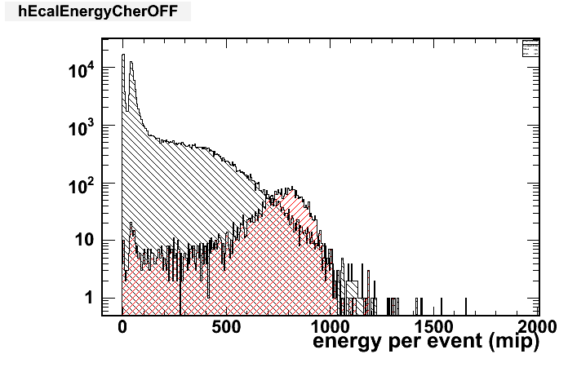

Figure 3.4: The total observed energy (in units of minimum ionising particles) in the AHCAL for incidence electron energies between 10 and 50 GeV (left). Observed AHCAL energy with (blue) and without (red) the ECAL in front (upper right). Observed AHCAL energy with (red) and without (black) a Cherenkov electron tag (lower right).

- Testbeam request for 2007

4.1. General considerations

Mean single particle energies in hadronic jets in ILC events are typically 6 to 12 GeV, but the spectra extend to 100 GeV and beyond. The test beams should thus cover an energy range starting in the few GeV regime and reach up to 100 GeV at least. Electrons and hadrons are obviously needed; muons are necessary in addition for calorimeter tracking studies and calibration. The range of particle incidence angles at the ILC is also large and suggests a flexible test set-up allowing for wide angular scans is needed at the test beam.
The beam must be well defined: the energy spread should stay within 1-2%, particle identification devices should allow particle selection with reasonably high purity, and tracking devices must define the impact for single events to better than 1 mm precision.
In order to estimate the sensitivities required to validate simulations, Monte Carlo studies using different hadron shower codes have been performed. Considerable differences are observed in both the ECAL and HCAL, and they vary with energy, particle type, and active detector material; both pions and protons need to be studied.
The number of different detector, particle type, energy and angular configurations to be tested is of order 10². Studies indicate detailed comparisons of data to known differences between simulation models would require around 10⁵ clean events for each of these configurations. This translates into a data sample of 10⁶ events per configuration being needed, not only to allow tight event selection to get rid of badly reconstructed or polluted events, but also to analyze the hadron shower data as a function of observables which cannot be pre-configured, such as the electromagnetic energy fraction, the number of hadronic interaction vertices, or the longitudinal and lateral containment. Such studies are needed for the optimization of both the single particle energy reconstruction using weighting methods, as well as for particle flow algorithm development.
The aim is therefore to collect a total data sample of around 10⁸ triggers, a similar total to that collected in 2006. There would be three main improvements for the 2007 datasets compared to the data already taken. Firstly, the ECAL would have complete lateral coverage. The Molière radius in tungsten is 9mm and so the 18x12cm² array used in 2006 was sufficient for EM showers but could not contain all hadronic showers which started in the ECAL. Such tails in hadronic showers, which can be at significant distances from the shower core, are one of the most difficult aspects of particle flow track-energy association to get right and as such are of great interest in this study. Secondly, the AHCAL will have full sampling granularity, rather than only having every other sensitive layer installed following the first eight layers. This will again allow more detailed understanding of the hadronic shower development. Thirdly, the movable stage means that the AHCAL and ECAL can be set at an inclined angle relative to the beam, giving non-normal incidence. Given the multi-Telsa magnetic fields planned for ILC detectors, it is critical to understand non-normal incidence for charged hadrons.
With a data taking rate of 100 Hz, the 10⁸ events would require less than two weeks if running continuously, which is of course not possible in practise. Changing the beam and detector setup for the various configurations needed, as well as general beam down time, will contribute to inefficiencies. A conservative estimate of an overall 50% running efficiency, based on our experience in 2006, therefore results in a requested period in the CERN beam line totalling four weeks for beam data. This time estimate assumes that low beam energies around 10 GeV can be provided to the H6 area for about half the running time, although our experience shows this can conflict with the requirements of other users. In addition, we request two weeks of parasitic calibration runs, recording muons while the beam is delivered to experiments upstream.

4.2. Experimental setup at the SPS
Overall, the needs in 2007 would be very similar to those in 2006. Specifically:
Mechanical integration: Our experience in 2006 means that we request to stay in the H6B beam area. We understand this beam and we know it is of sufficient quality, and has enough room, for our needs. The movable stage will occupy a significantly larger floor area than required in 2006 although the mechanical integration of the proposed 2007 set-up has already been studied during the preparations for 2006, see Figure 4.1.
Installation: Some of the equipment needed has been left in the H6B beamline during the winter shutdown, in the hope that we can use the same area in 2007. The rest has been shipped back to DESY to integrate with the HCAL movable stage. The time needed for assembly of the calorimeters and the movable stage in the experimental area is estimated to be 5 working days. Another 5 days will be required to recommission the DAQ. The tail catcher remains in place from 2006.

Instrumentation: We request the use of three (or more) CERN delay wire chambers (DWC) as tracking devices for the event-by-event determination of the particle impact trajectory, as supplied in 2006.
For electron-hadron separation in the momentum range under consideration, we would like to use the Cherenkov counter as in 2006. A second counter in 2007 for proton separation would be highly desirable.
The group will provide their own trigger devices (scintillation counters) as previously.
Further infrastructure requirements: We again ask CERN for the provision of network access, electrical power, a gas supply for the beam instrumentation devices (DWC, Cherenkovs), technical support to move and install the detectors and some expertise to help and support the beam line operation. We need a temporary counting room, office and meeting space and we would like to occupy the same rooms as in 2006, if possible. One room needs to be equipped with a good quality speaker phone. For 2007, some additional office space away from the beam area would be highly desirable.

4.3. Test beam programme
The request is for two periods of two weeks each, with three or four weeks between the two to allow for analysis and optimisation of the system. Before the first period, we would also request at least two weeks when the beam line is being used by other experiments upstream so that we could run parasitically. This would allow a cross check and recalibration of the calorimeters before the start of our data-taking period. Previous to this, we would need a minimum of two weeks with access during which we could reinstall the ECAL, AHCAL, and movable stage, and recommission the readout and data processing chain.
Due to other constraints from the LCWS07 conference at DESY, it would be difficult to commence the installation before the second week of June. Hence, our ideal schedule would be to reinstall in the second and third week of June, run parasitically for two weeks from the end of June, have the first data-taking period early in July and then have the second period at the end of August. Shifting this schedule later by a week or so would be possible, but earlier would cause significant difficulties.
The actual test beam programme would start by duplicating some of the previous runs taken in 2006 at normal incidence to cross-check for consistency. The main bulk of the data-taking would then be devoted to non-normal incidence running over the full range of beam energies and with both electrons and pions. Any remaining time following this would be devoted to high statistics normal incidence runs, duplicating the 2006 data but with completed calorimeters.
If there was a possibility of being granted a total run time beyond the four weeks requested, we would be well able to take good advantage of the opportunity. In particular, the low energy (below 10 GeV) hadronic showers are where discrepancies between hadronic shower models appear to be largest and are also the average hadronic energies in ILC jets. However in this range, the H6 beam rate is low, and in addition experience in 2006 has shown that this energy range cannot always be provided when requested due to conflicts with users in the H8 beam line. Hence, further running to build up more statistics at low energies would be very desirable. Secondly, another Cherenkov to tag protons would allow a cleaner comparison with simulation. However, this would take some time to commission and so could best be done during an extended run period.
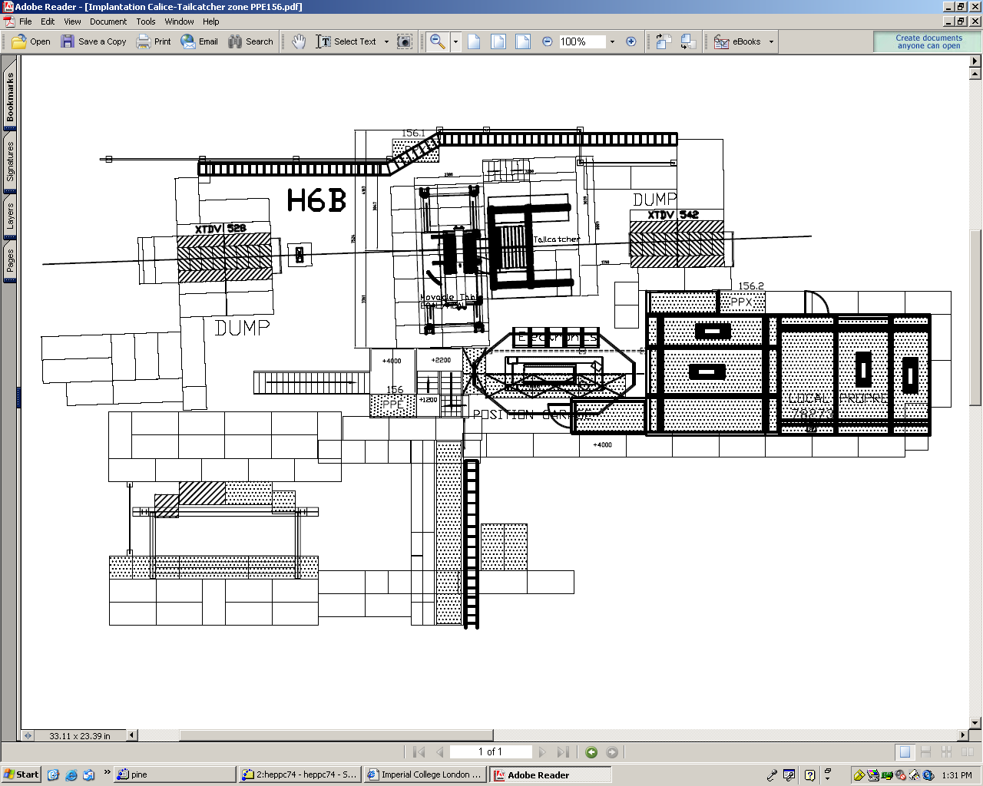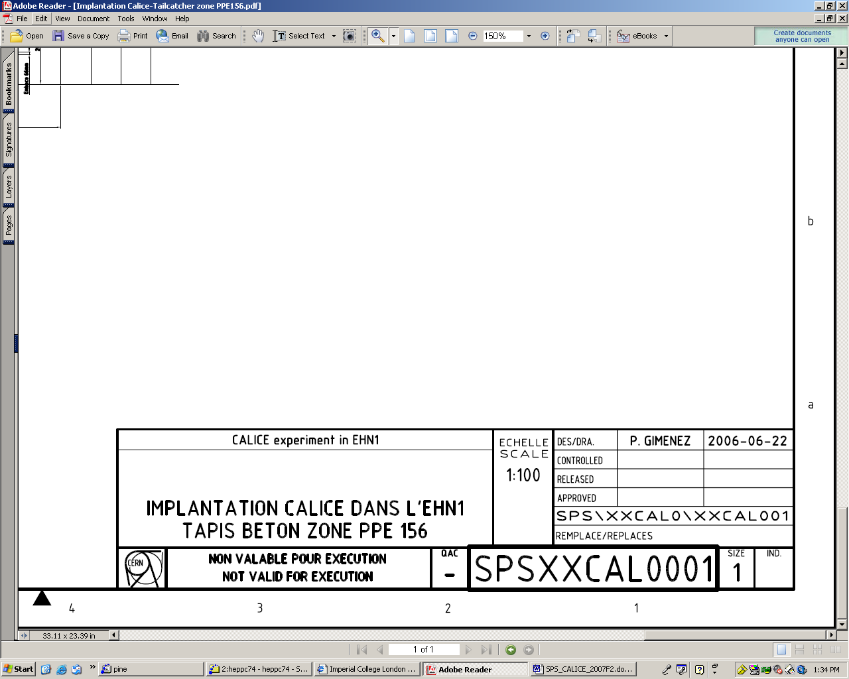

Figure 4.1: Integration of the proposed 2007 CALICE installation, including the movable stage, into the beam area H6B

