Conference Contribution 

Silicon-Tungsten Electromagnetic Calorimeter
for experiments on the future e⁺e– linear collider

CALICE Collaboration*

Abstract:
A high granularity 3D calorimeter providing a detailed picture of the shower, adequate for efficient pattern recognition and needed energy resolution is mandatory for exploiting the discovery potential of the planned e⁺e– linear collider. For the electromagnetic calorimeter, the CALICE collaboration proposes a highly granular tungsten-silicon sampling calorimeter. The silicon device is made of PIN diode matrices with readout pads of 1x1 cm². Such a calorimeter suits perfectly the energy flow measurements and enables a detailed event reconstruction. The measurements of prototype pads silicon arrays are presented.
CALICE collaboration

S.Chekanov, G.Drake, S.Kuhlmann, S.R.Magill, B.Musgrave, J.Proudfoot, J.Repond, R.Stanek, R.Yoshida
Argonne National Laboratory
A.Brandt, K.De, S.Habib, V.Kaushik, J.Li, M.Sosebee, A.White, J.Yu
University of Texas at Arlington G. Blazey , D. Chakraborty, A. Dychkant, A. Maciel, M. Martin , R. McIntosh, V. Rykalin, V. Zutshi
NICADD - North Illinois University , Batavia
C.M.Hawkes,S.J.Hillier,R.J.Staley,N.K.Watson
School of Physics and Astronomy, University of Birmingham
C.G.Ainsley,G.MavromanolakisM.A.Thomson,D.R.Ward
Cavendish Laboratory, Cambridge University F.Badaud, G.Bohner, F.Chandez, P.Gay, J. Lecoq, S.Manen, S.Monteil
Laboratoire de Physique Corpusculaire - Clermont
V.Astakhov, S.Golovatyuk, I.Golutvin, A.Malakhov, I.Tyapkin, Y.Zanevski, A.Zintchenko , S.Bazylev, N.Gorbunov, S.Slepnev
Joint Institute for Nuclear Research – Dubna A.Baird, R.Halsall Rutherford Appleton Laboratory – Didcot G.Eigen, E.Garutti, V.Korbel, R.Poeschl, A.Raspereza, F.Sefkow DESY - Hamburg M.Groll, R.-D. Heuer, S.Reiche Hamburg university
D-W.Kim, G-B.Kim, K.Lee, S.Lee , M. Naim-Il Baik
Kangnung National University - HEP/PD - Kangnung
D. Bowerman, P. Dauncey,C. Fry, D.Price, O. Zorba
Department of Physics,Imperial College London
S. Boogert, J.M.Butterworth, D.J.Miller, M.Postranecky ,M.Warren
Department of Physics and Astronomy,University College London
R.J.Barlow, I.P.Duerdoth, N.M.Malden ,D. Mercer, R.J.Thompson
Department of Physics and Astronomy, The University of Manchester
N.Shumeiko, A.Litomin, P.Starovoitov, V.Rumiantsev, O.Dvornikov,V.Tchekhovsky, A.Solin, A.Tikhonov
Joint Institute for Nuclear Research - Minsk
M.Danilov, V.Kochetkov, V.Morgunov, V. Rusinov, S.Shuvalov, E.Tarkovsky Institute of Theoretical and Experimental Physics – Moscow E.Devitsin, V.Kozlov, L.Popov, S.Potashov, A.Terkulov
Lebedev Physics Institute - Moscow
P.Buzhan, B.Dolgoshein, A.Ilyin, V.Kantserov, V.Kaplin, A.Karakash,E.Popova, S.Smirnov
Moscow Engineering and Physics Institute
P.Ermolov, D.Karmanov, M.Merkin, A.Savin, A.Voronin, V.Volkov
Moscow State University A.Brandin, A.Ridiger
State Research Center "INTERPHYSIKA" , Moscow
B.Bouquet, J.Fleury, G.Martin, F.Richard, Ch. de la Taille, Z.Zhang
Laboratoire de l'Accélérateur Linéaire - Orsay
M.Anduze, J.Badier, J-C.Brient, A.Busata, S.Cholet, F.Gastaldi,A.Karar,C. Lo Bianco, P.Mora de Freitas, G.Musat, A.Rouge, J-C. Vanel, H.Videau
Laboratoire Leprince Ringuet - Ecole Polytechnique - Palaiseau
Y.Bonnassieux, P.Roca
Physique des Interfaces et Couches Minces - Ecole Polytechnique - Palaiseau
A. Savoy-Navarro
LPNHE - Université Paris6/7
J.Cvach, M.Janata, M.Lokajicek, S.Nemecek, I.Polak, J.Popule,M.Tomasek, P.Sicho, V.Vrba, J.Weichert
Institute of Physics, Academy of Sciences of the Czech Republic - Prague
S.Valkar, J.Zacek
Charles University - Prague
V. Ammosov, Yu.Arestov, B.Chuiko, V.Ermolaev,V.Gapienko, A.Gerasimov,Y.Gilitski,V.Koreshev, V.Lishin, V.Medvedev, A.Semak, V.Shelekhov, Yu.Sviridov,E.Usenko, V.Zaets, A.Zakharov
Institute of High Energy Physics - Protvino
Ilgoo Kim, Taeyun Lee, Jaehong Park, Jinho Sung
School of Electric Engineering and Computing Science, Seoul National University

1. Introduction
The physics program at a future e⁺e– linear collider (FLC) running at center of mass energy from the Z peak to about 1 TeV, is largely dominated by multi-bosons final state, i.e. up to 3 bosons with a mix up of Z, W± and Higgs. In order to fully exploit the accelerator luminosity, bosons decaying to jets must be used and a good boson identification and energy/direction reconstruction is therefore mandatory. This point is illustrated by the separation of the ZZ and WW in the reaction e⁺e– → W⁺W– ν ν and e⁺e– → ZZ νν, where each boson decays to 2 jets. These final states contain 4 jets, which are paired by choosing the smallest mass difference between the two di-jet masses. Figure 1 shows the plan of the 2 di-jets masses for two different energy/direction resolutions of the jets, one with ∆E ~ 0.3 √E (on the right) corresponding to the TDR detector performances and one with ∆E ~ 0.6 √E (on the left), which is roughly the LEP detector’s performances.
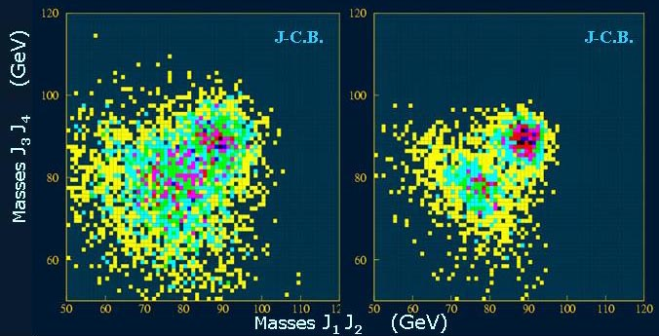
Figure 1 : Distribution of events in the plane of the two di-jets masses for the LEP type of resolution on jets (left) and for the proposed improved resolution (right)

Reconstruction of jets in multi-jet final states is therefore the major goal of the detector and it was the guideline in the design studies for the TDR [1]. It has been shown that an overall particle reconstruction, improperly called “Energy Flow” (EFLOW) is the best method to reach a very good resolution on the jets energy/direction [2]. This method consists in reconstructing individually all visible particles. Under this condition, efficient pattern recognition is very important and the resolution on jets depends more on the imperfect recognition than on the finite energy resolution for individual particle. One of the ways to perform it consists in instrumenting calorimeters with a high degree of tracking capabilities, which enable a reliable track-shower association and energy identification. To optimize the track-shower association, both the electromagnetic (ECAL) and hadronic (HCAL) calorimeter must be put inside the coil, like it is shown in figure 1, avoiding any blind region in the middle of the shower development. Therefore, the available space for both calorimeters is given by the internal radius of the coil and a compact ECAL is mandatory to have enough interaction length for the HCAL.

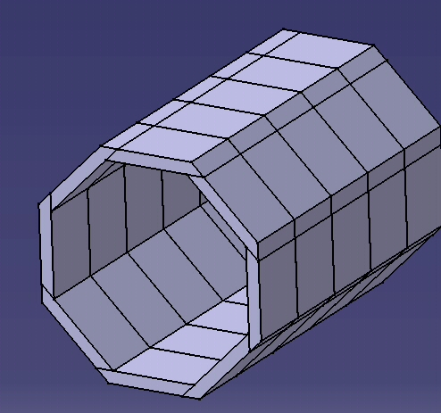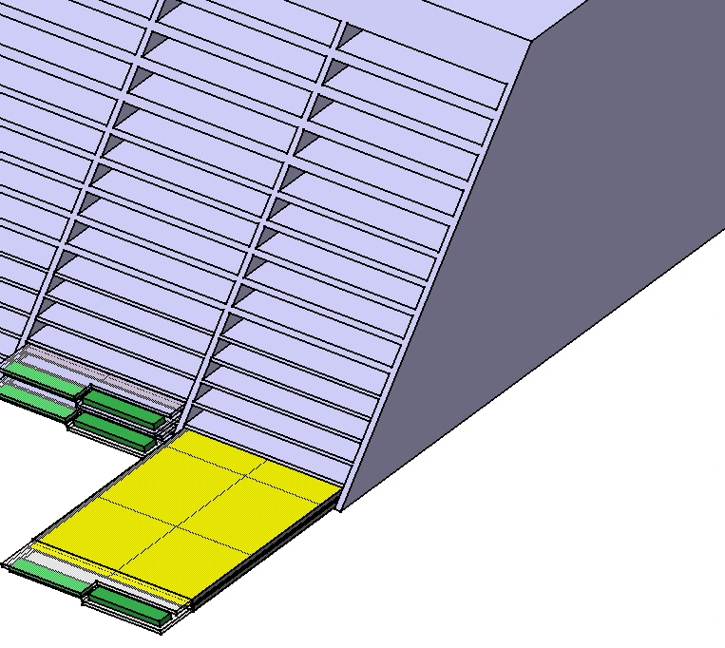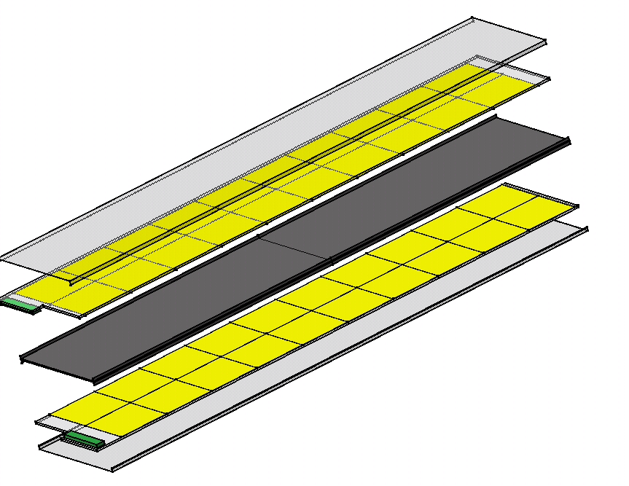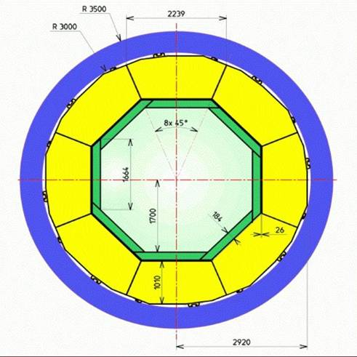
External border of the module
TPC
ECAL
HCAL
coil

Octant
Detector slab
figure 1: Cross section of the barrel part of the detection system (top left)
and basic construction elements of the electromagnetic calorimeter.

In addition, it has been shown that a “tracking calorimeter” could be the right choice
to optimize the performance of the pattern recognition, since it produces a 3D view of the shower development inside the calorimeter. Such a calorimeter must have a large segmentation with small readout pad size and a good shower to shower separation, i.e. a small Molière radius but also a small hadronic shower spatial dispersion. Basic construction units of the electromagnetic calorimeter are modules, mechanical stiffness of which is ensured by a carbon fiber skeleton, minimizing the dead region.

2. Electromagnetic calorimeter concept
All these considerations led to choose high density and Z number material for the radiator going naturally for the tungsten, which has a Molière radius r_{M} of 9mm and a radiation length (X₀) of 3.5 mm. For the active part of the device, silicon PIN diodes seem perfect but their cost. The individual e.m. energy resolution needed and the future cost evolution will drive the area of silicon and therefore the number of layers. Many studies have been done with 40 layers, as given in the TESLA TDR [1], while a prototype under construction will have only 30 layers. The pad size comes from a compromise between the density of extraction lines of the readout, the electronics cost together with a pad size not much larger than the Molière radius. For the studies as well as for the device in construction, a pad size of 1x1cm² has been adopted.

The basic detection units are detector slabs (Fig. 2) which consist in a stiffening H-structure from carbon fiber material embedding a tungsten sheet and overlaid by silicon pad sensors. The entire slab is shielded by an aluminum envelope and is slit into the module.

As it is shown in fig.2, for the final project, one of the possible geometrical designs locate the VFE chip inside the detector. That will be possible only if the power dissipation is not too high, if the duty cycle could reduce it efficiently and/or a cooling system could be designed for such a thin device, and if a 500 GeV e.m. shower crossing the VFE chip would not disturb it too strongly. All these points are part of the CALICE R&D program. Insuring the behavior of the ECAL prototype in the test beam, for the prototype, the VFE chip are located outside, on the external part of the PCB.

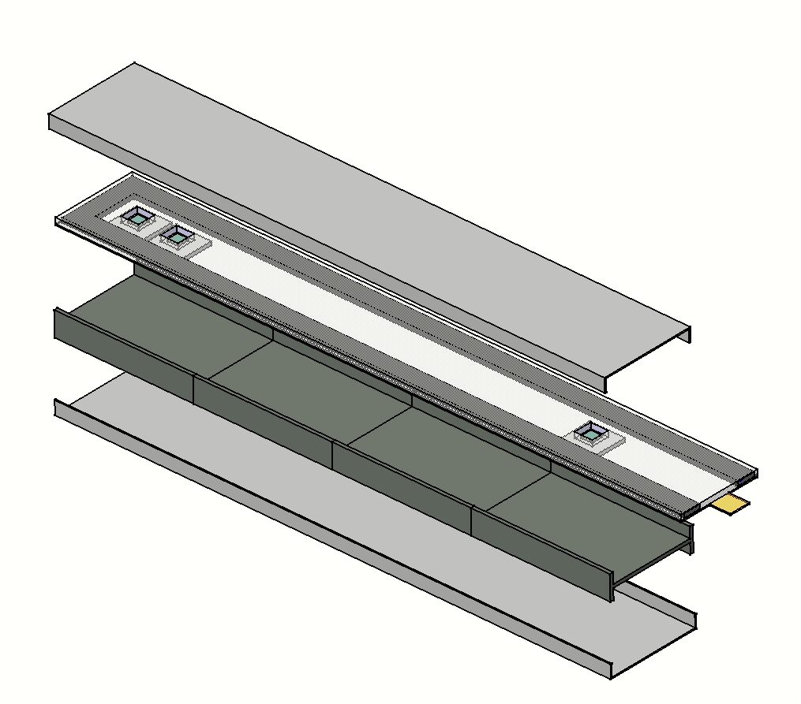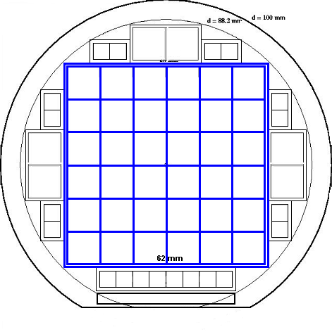
(C / W) structure type H
Front End electronics
Cooling system
Aluminum
shielding
Silicon sensor array
sensor pad
1 x 1 cm²
Fig. 2: Schematic view of a possible detector slab

3. Current status of the project
The CALICE project has been proposed to the DESY “Physics Review Committee” which approved it as PRC 02-01. The agenda of the project concerns also the construction of a prototype, with test beam at the end of 2004 with low energy electron, and high energy hadrons and electrons in the year 2005-2006. The test with hadrons beam is foreseen to be done together with the different HCAL options of CALICE. Today, the options are namely the analogical HCAL based on scintillator tile with stainless steel for radiator, and the so-called digital HCAL, where the readout of the active device works in binary mode, i.e. yes/no (1bit). In this later case, the number of pads hits is, following the GEANT4 simulation, linear with the incoming hadron energy. Similar behaviour is foreseen with the ECAL, but with a strong saturation effect for energies higher than about 1 to 2 GeV.

4. The ECAL prototype
4.1 General description
The ECAL prototype mimics the final project with tungsten wrapped in carbon fiber, with 30 layers and a pad size of 1x1cm² but the very front end (VFE) electronics is located outside the device, on the same PCB on which the silicon wafers are glued. The schematic view of the prototype is shown on fig. 3, with different color for the three stacks, each one with different tungsten thickness. This choice ensures a good resolution at low energy, due to the tin tungsten in the first stack, and a good containment of the e.m. shower due to a tungsten thickness 3 times larger in the third stack. The overall thickness is about 20 cm or 24X0.
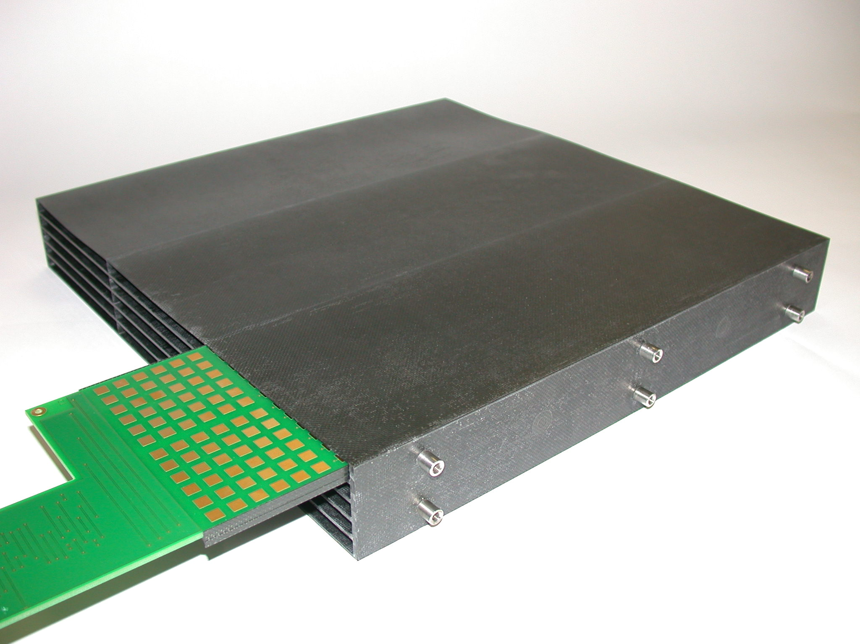
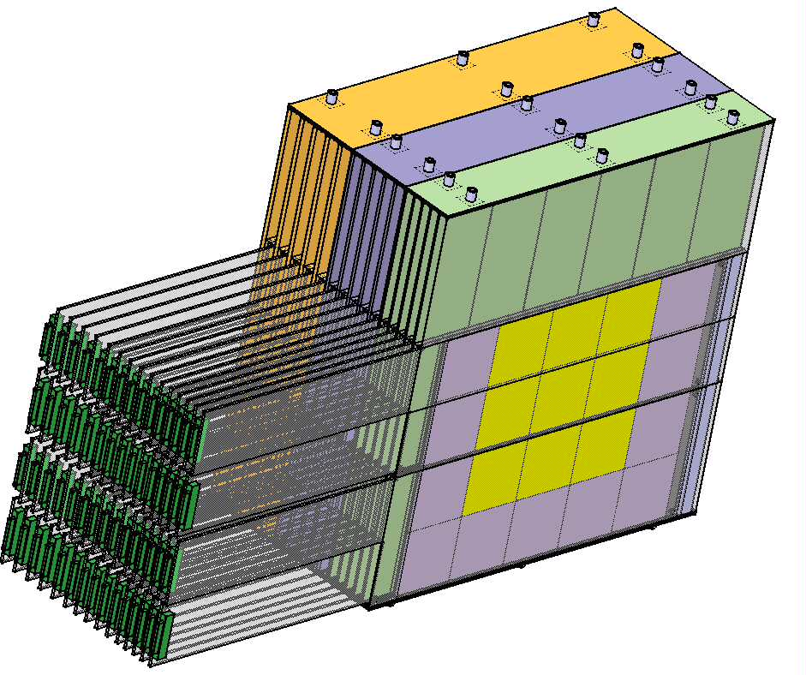
Figure 3: Schematic view of the prototype Figure 4: real structure of the stack 1

The structure is realized by carbon fiber wrapping half of the tungsten sheet, leaving free space between each tungsten sheet, called alveoli. In these free spaces, detector slabs are slit. The LLR group has already produced the first stack structure as it is shown in Fig.4. The detector slab consists of 2 active readout layers and one tungsten sheet. The active layer is made of PCB 14 layers (2.1mm) and 500 microns high resistivity silicon wafers. The PCB has been designed at LAL and the production will be made in Korea under the control of KNU. The wafers have been processed in Russia at MSU and a production will soon begin in Prague under control of IOP-ASCR and Charles University.

4.2 The active device
The wafers are cut in matrices of 62x62 mm with 36 pads, while the space reserved for the guard ring is about 1mm. It must be noted that there is only one set of guard ring per matrix. The first batch of the production, made in Russia, managed by the MSU group, is of very high quality, with a typical leakage current less than few nA/pad for all the pads, but for few per cent of the production, where 1 or 2 pads among the 36 of a matrix goes up to 20 nA/pad. The matrix will work in overdepleted mode around 250V. The connection to the PCB is realized by conductive glue for each pad, with an AC coupling mode of for the readout. For the final project, it is considered to use amorphous silicon deposited directly on the pad, to make the resistance and capacitance. It is the object of an R&D program inside the CALICE-ECAL groups. For the prototype, the AC coupling is realized using discrete components put directly on the PCB, before the amplification in the VFE chip.

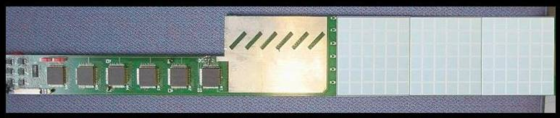
Figure 5: Test PCB with 3 silicon matrix glued and VFE located on the left part of the PCB

4.3 The very front end electronics
The PIN diodes are read by a VFE chip developed by the LAL-Orsay group. It consists in a preamplifier with two gains, a shaper and a multiplexer. This chip treats 18 channels, with low noise, high dynamical range. The results are a 0.2% linearity, a signal uniformity better than 2% and less than 0.2% of cross talk. All of these are measured value over the 600 MIPS of dynamical range. The PCB with the silicon matrix and the VFE on the side is shown on fig. 5

Amp
OPA
OPA
G1
G10
1 channel
Figure 6: Schematic view of the VFE chip

The schematic view of the VFE is presented in fig. 6, while the first results on the signal uniformity and the noise are given in figure 7. The values come from the test and measurements perform on the version 2 of the chip, at the return from foundry.

4.4 Assembling and testing
One of the important advantages of the silicium is the response stability with time and temperature. In order to check it, the detector will be calibrated with cosmic muons using a test bench developed at the LLR, before going on real test beam in DESY at the end of 2004. A dedicated DAQ system has been developed, working on a single PCB, and based on National Instrument PCI board with 32 differential input channels, able to read a single detector slab. The calibration at the m.i.p. level will also be used to intercalibrate the different channels, since the wafer thickness is known only with a tolerance of ±3%, as given by the wafers producers.
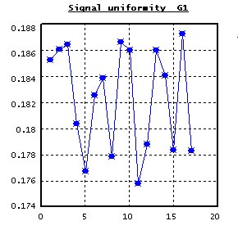
Figure 7: The signal uniformity (left), well within 2%, and the noise distribution (right)

Such a variation of thickness could be one of the major components of the constant term of the calorimeter. Taking into account this effect, could improve drastically the energy resolution. This DAQ has been used to produce the first measurement of the m.i.p., on a full chain of detection, namely:

Silicon diodes – Conductive glue – PCB – VFE – DAQ

This measurement is shown in fig. 8. It shows a total noise at the level of ¼ of a m.i.p. and a m.i.p. signal about at the expected place of 40 000 e-.

Expected mip position
Figure 8: the m.i.p. signal in the detector slab(histogram),
together with the noise distribution (yellow line)

For the test of the detector slab assembly, and together with the wafer intercalibration, a cosmic test bench has been developed. Four functions are implemented, Scintillators-PM, Trigger, Command generator, and Acquisition. The detection system is made of 2 planes of scintillators read by PM. The trigger is then defined as usual by time coincidence between 2 PM’s from two different planes. The generated trigger is put in a NIM format, ready to be used by any DAQ. For the individual detector slab DAQ, it has been decided to use a commercial board from National Instrument, with
- 32 multiplexed differential channels
- a sampling rate at 1.25 Mb/s per channel
- a dynamical range of 12 bits and an interface PCI 32 bits.

Such a board allows to process individual detector slab in stand alone, for the test and calibration.
Figure 9: A schematic view of the cosmic test bench, with the DAQ for
the assembling test and calibration of the detector slab.

The signal generator card is built using a XILINX CPLD, with master clock from the DAQ board, but with possible connexion to an internal clock. The signal transmission is in LVDS, through a TTL translator. Slow control and calibration for each detector slab run under USB. The calibration can be performed in two modes, one in USB, with readout and validation goes through the USB port and one with external validation. The injected value could be done from the ADC output on the DAQ board, or from a totally external node, with the TTL translator.

4.5 The DAQ for the prototype
The readout of the full prototype, where there are about 10,000 channels, will be done with a custom designed VME readout board. This has been developed by the UK groups and is based on the CMS tracker readout. The timing, multiplexing and calibration control signals for the VFE board are sent in LVDS by the readout board, with the actual VFE channel outputs being returned as a differential analogue signal. The multiplexed outputs are digitised on the readout card using a 16-bit, 500 kHz ADC, which should allow complete readout from the VFE within 100 μs. The resulting ADC data are buffered on board in an
8 MByte memory, allowing up to 2000 events to be stored before VME access is needed. This should allow an event rate above 1 kHz during a spill with the aim being to achieve an average of more than 100Hz over a run. Two prototype readout boards are under test and the full system of six boards is scheduled for fabrication in summer 2004

5.The first simulation and tests
A simulation of the prototype, based on GEANT4, has been developed, using a framework and interface program called MOKKA [3]. First results and tests have been performed, like the dynamical range for electrons up to 50 GeV when starting to about half a m.i.p., the importance of the dead zone between wafers if consecutive layers are not staggered, the first set of physics variables to test, such as lateral dispersion, longitudinal profile, energy resolution, etc..
A new simulation version, with a very precise description of the mechanics and readout
is under development at LLR for the ECAL, at DESY for the tile HCAL and at ANL and NIU for the digital HCAL. It will be release in the first months of 2004.

6.The schedule of the tests
At the end of the year 2003, the status of the ECAL prototype is the following:

- Good quality silicon matrices are in production and test at MSU and IOP-Prague. About half of the needed wafers are already produced.

➢ All the needed tungsten sheets have been produced. The carbon fiber-tungsten structures are in fabrication. The needed tools for assembling is ready at LLR

➢ The 14 layer PCB which support the wafers, designed in LAL are now in
production in Korea at KNU.

➢ VFE electronics is under production, after design and test at LAL, LLR

➢ ADC-DAQ boards will be tested in spring before production in summer 2004
under the control of the involved UK laboratories.

➢ Preparation for testing with cosmic muons at LLR is in progress for a general test of
the prototype.

The first test beam is planned at DESY in the fall of 2004.

7.Conclusion
The CALICE collaboration is preparing actively the ECAL prototype for the test beam foreseen in 2004-2006. A matrix of silicon PIN diodes has been read through conductive glued on a dedicated 14 layers PCB are amplified by VFE custom chip and read by test DAQ. The signal collection is good and the overall ENC is at the level of ¼ of mip. The assembly at LLR-Ecole polytechnique will start in spring 2004 and a cosmic test bench will be used to intercalibrate and test the mounting for individual detector slab. The general DAQ is under development in UK laboratories and the needed VME boards will be produced in summer 2004. A first test beam period is planed for fall 2004 at DESY with low energy electron. The general test beam period is foreseen in 2005-2006, with the two HCAL options of the CALICE collaboration.

REFERENCES

[1] Calorimeter section, TESLA Technical design Report PART IV,
DESY 2001-001, ECFA 2001-209, March 2001,

[2] A calorimeter for Energy Flow,
presented by J.C. Brient , LCWS99, Sitges, Spain

A W-Si electromagnetic calorimeter for Higgs physics at a linear collider,
presented by H.Videau , LCWS2000, Fermilab, USA

[3] MOKKA , A simulation package of the FLC detector, based on GEANT4
http://polywww.in2p3.fr/geant4/tesla/www/mokka/mokka.html

* CALICE Collaboration: Argonne National Laboratory, Univ. of Texas-Arlington, NIU Batavia, Univ. of Birmingham, Cambridge University, LPC-Clermont, JINR-Dubna, DESY-Hamburg, Hamburg University, Univ.of Kangnung, Imperial College London, Univ. College London, Univ. of Manchester, JINR Minsk, ITEP Moscow, Lebedev Inst. Moscow, MEPHI Moscow, Moscow State University, SRC Interphysika Moscow, LAL-Orsay, LLR-Palaiseau, PICM Palaiseau, LPNHE Université de Paris 6/7, Institute of Physics and Charles University Prague, IHEP Protvino, Seoul National University, Tashkent University CALICE WEB SITE : http://polywww.in2p3.fr/flc/calice.html

