CMS FED VME interface chip
By Edward Freeman
29/10/03
for VME_11_00
and VME_03_02
Draft V0.1

The VME chip contains the VME interface and a few other functions to control the FED including reset distribution, clocks and clock selection.
The interface is designed to work in a VME64x back-panel but does not implement all of the VME64x functions at this time. It is fully VME64 compliant as there is no requirement for all the functions to be implemented for an interface to be compliant.
A full register map can be found at the end of the document. Although there use is explained with the relevant block.

The VME chip has four main “FED functional” parts: -

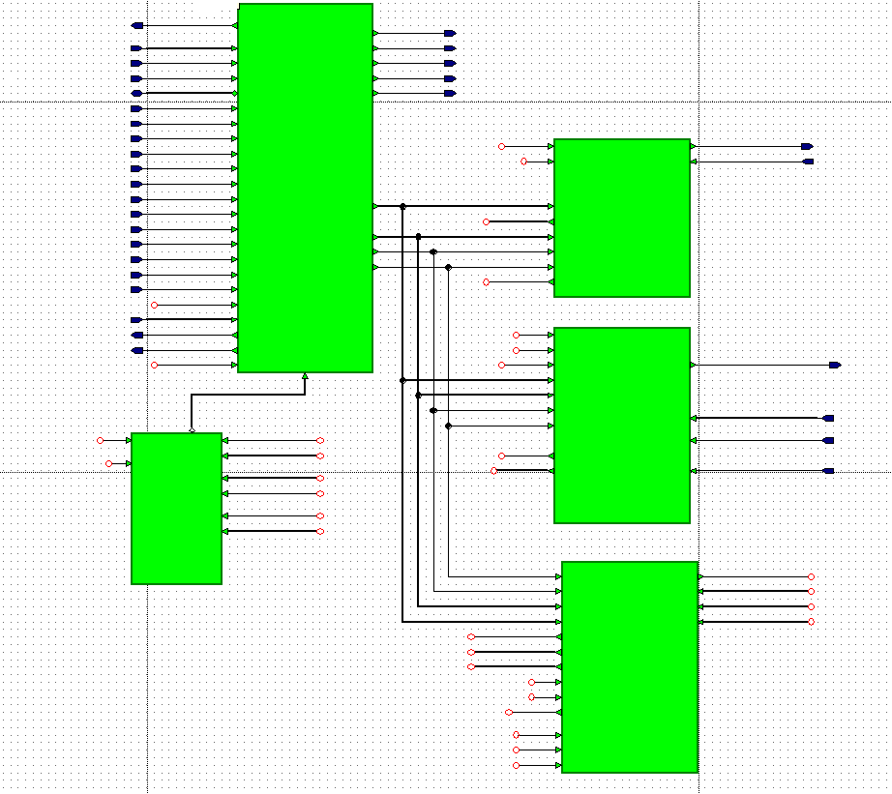
1) VME Interface
MUX
2) Serialiser
3) Vlink
4) Management

1) The VME interface.
Converts from the asynchronous VME bus to a simple synchronous bus.
This part is responsible for the VME bus interface and making sure the system is VME compliant. This part implements all the VME functions like Block-Transfer (BT) and Geographic Addressing.

32bit data and 32bit address is supported but there is no support for 8,16 and 24bit transactions as there was no perceived need for these smaller sizes, especially as they would be no quicker per read/write cycle. There is also no support for 64bit data but this could be added if the increase in speed is needed. (Twice the data size would almost double the speed)
The interface only supports aligned data i.e. the 32bits start at the 8bit address’s ending with hex values 0,4,8 and C. i.e. $xxx0, $xxx4, $xxx8 or $xxxC.

32bit BT is supported within the confines of the VME specification.
This means all BT’s must start and end with in the same 256KB block.

Geographic addressing. (GA)
As it stands now the Geographic Address (GA) pins are only used to tell into witch slot the card is inserted. If the card detects its in either the slot one controller place or is in an old back panel then it will assert a bus error. (The FED card will probably not power cycle if it’s in a non-VME64 back panel See power supply documentation).
If the card is in a valid slot then the slot number becomes the top part of the card address range.
I.e. if the FED is in slot No. 17 then the base address of the card would be hex $00110000 and if it was in slot 18 then its base address would be $00120000.
At the moment, there are no Configuration Register or Control and Status Register (CR/CSR). Because of this there is no “plug and play” type configuration implemented at the moment. With in these limits the VME chip is fully VME64 compliant.

2) Serialiser
The serial command system is designed to be small and to not affect timing in the complex Front-End (FE) chip. It bridges the simple synchronous bus to a serial stream to control the Back End (BE) and all the FE chips. Because of this, it isn't the simplest interface to control and some of the complexity has been pushed into software.

The software is responsible for assembling the serial command, putting it into the read or write register respectively and then triggering it by writing the length of command to a third register.
The commands are of a standard format for all the chips with the form of: -

<1><5bit target ID><1><r/w><1><5bit designator><16bit length><arguments>

The 5bit target ID specifies which chip the command is to be sent to: -
1 FE chip 1
2 FE chip 2
3 FE chip 3
4 FE chip 4
5 FE chip 5
6 FE chip 6
7 FE chip 7
8 FE chip 8
9 Soft trigger (for debug only)
10 BE chip
15 Broadcast to all FE chips

A serial write cycle: -

Once the software has assembled the command in its memory it puts it in the bottom of the “Serial command and results” RAM ($0000). If the command is longer than 32 bits then the second part of the command is placed in the location above ($0004). The command is shifted out starting with the LSB of the first register to the MSB then the LSB of the second register though to the MSB.

$000C

$0008

$0004

$0000
LSB
MSB

Once the command is set, up in the “serial command and results" RAM the length in 32bit words is written to the “Write command serial” register the act of writing to this resister starts the Serialiser.
The controlling software can then pole the “status serial” register ($080C) to see when the Serialiser is finished “FFFFFFFF” is free for new commands and zero means the Serialiser is busy.
It is a good idea to make sure the register above the last part of the command is clear (i.e. clear $0008 before writing to the “Write command serial” register for this example)

Any spare bits in any of the registers should be set to zero but the serial commands work by their position compared to the 1st bit so no extra zeros should be placed in the middle of a command. The command should be shifted so that any spare bits are at the beginning or end of the command.
Commands can be chained together in the RAM and fired off together. It is advisable to leave a second blank 32bits between each command if commands are to be chained. This is to allow the serial chain to settle before the next command is started. The value written to the “Write command serial” register in this situation would be the total number of 32bit register used including blanks.

A serial read command: -

The read command works in a similar way to the write only it doesn’t use the “serial command and results” RAM for the command itself only for storing the results of the operation.

Once the software has assembled the command it writes it to the “Read command serial” register. The act of writing to this register starts the Serialiser.
For the delay chips spy data readout command a second read register is also needed.
The results of the command are then put into the “serial command and results” RAM in the format they come back in.
For more information on the serial commands for the FE and delay chips see the “FE Technical description v1.3”. For more information on the commands for the BE chip see “BE draft notes” both on the CMS FED web page. Individual command specifications contain the formats for different commands return data)

3) Slink to VME Bridge. (Vlink)

Connects Slink read out data to the VME interface.
This block is designed to look as much like the Slink to the BE chip as possible so as to simplify the job of interfacing the BE chip to both the Slink and the VME interface.
The interface consists of 32bit wide DDR data input and three control strobes.
The control strobes are called Data Enable, Throttle and CNTRL.
All three lines work together to provide flow control and framing for the data.

The CNTRL line toggles high for one clock cycle at the beginning and end of each data frame. A frame can be of any length as far as the Vlink is concerned although this is limited by other chips.
The Data Enable line is high when there is valid data coming in on the DDR bus from the BE chip and low at other times.
Throttle is used by the VME chip to tell the BE chip to stop sending data because the VME chip is full. There is an allowed latency on this process of up to seven clock cycles before the data stops. This is up to 14 32bit words of data.
CNTRL
Data_Enable
Data
Data
Data

Throttle

The VME interface controls the data flow within the Vlink by the use of four registers: -
$0820 Amount in RAM for VME to read out
$0824 Event No.
$0828 Event length
$082C event ready/last part

The Amount in RAM for VME to read out this is represented in whole 32bit words. I.e. 39bits of data would have a size of two words in this register. This is reset after the RAM is readout by the clearing of the ready flag by software.

The Event Number increments every event. I.e. every pair of CNTRL pulses. The first event is event No. 1.

Event length is the total length of the event so far. For the 1st part of a long frame it will read the same as the Amount in ram counter but will keep counting until the end of the event.

Event ready/last part is the flags that are used to control data flow.
The LSB of this register is run_stop but and the second bit is used to signify the last part of an event.
The run_stop bit is set to ‘1’ by the system when the RAM is full and throttle flag enabled this stops overwriting the of the existing data.
After the VME control, software has read the data from the Vlink RAM it clears the event ready/last resister to signify the next part can be processed.
The “last” bit is set high when the Vlink RAM contains the last part of the event shown in the event counter.

4) Management block
This block deals with clock selection, revision No., status register and the software resets. It has a lot of I/O compared to other blocks as most of its values are picked up from the top level of the design. The TTC and BP counters are just counters that are attached to the TTC and BP clocks and if they are toggling then the counters will be. These doses not imply the DCM’s are locked or clocking properly just that there are transitions on that clock line. The FED ID is stored on the top level so it can easy be changed.
The two resets are only operated on a write command so they don’t operate if reading a range of addresses including the reset registers.
This block also has the register for the clock select although the logic for this is on the top level. The register works on a “one hot” principle with the first, second and third bits having the meanings of: -

1st bit On board oscillator.
2nd bit TTC clock.
3rd bit Back panel clock.

If the command is sent to change to a clock that doesn’t exist then the system will switch back to the on board oscillator automatically.
A DCM reset is advisable before and after a clock switch to make sure all the DCM’s are locked and functioning correctly.

Structure of VME interface block

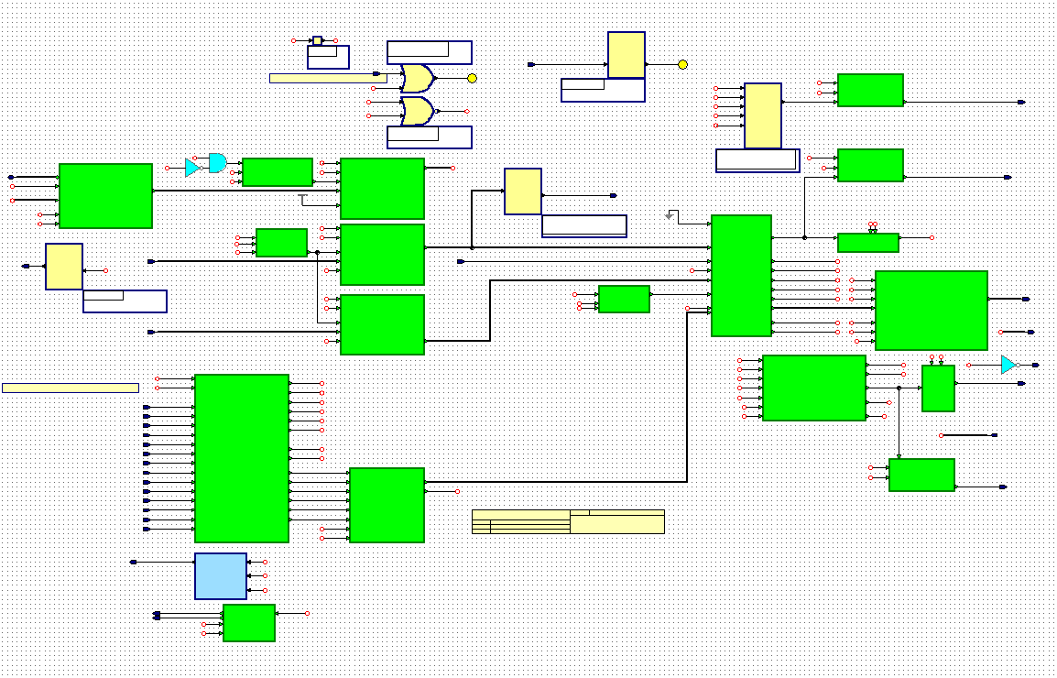
1)
2)
3)
4)
5)
6)
7)
8)
9)
9)
10)
11)
9)

The ports to the left of the picture are the VME buses while the ports to the right hand side form the internal synchronous bus.

- Tri state driver for the data lines. Drives for outputs reads for inputs and is ‘Z’ for the rest of the time
- Data latch. Latches the data when the data strobes indicate data is valid on bus
- Address latch. Latches the address when the address strobe indicates the address is valid on bus.
- Address modifier latch. Latches the address modifier.
- Asynchronous to synchronous converter. Moves all signals into the clocked domain.
- Geographic address decoder. Checks the Geographic address and parity.
- Dtack manager. Drives Dtack and the Dtack direction line to enable tri stating.
- Address modifier decoder. Decodes AM code to find what sort of bus cycle it is.
- LED flash once. Takes single pulses and makes the longer so they can be seen on an LED. For read write light and access light.
- Increment address. Provides the address generation for block transfers.
- Write_control_32b is a FSM that sequences the other parts in this diagram so that they function together.

The other blocks are simple ‘glue’ logic.

Structure of Serialiser block

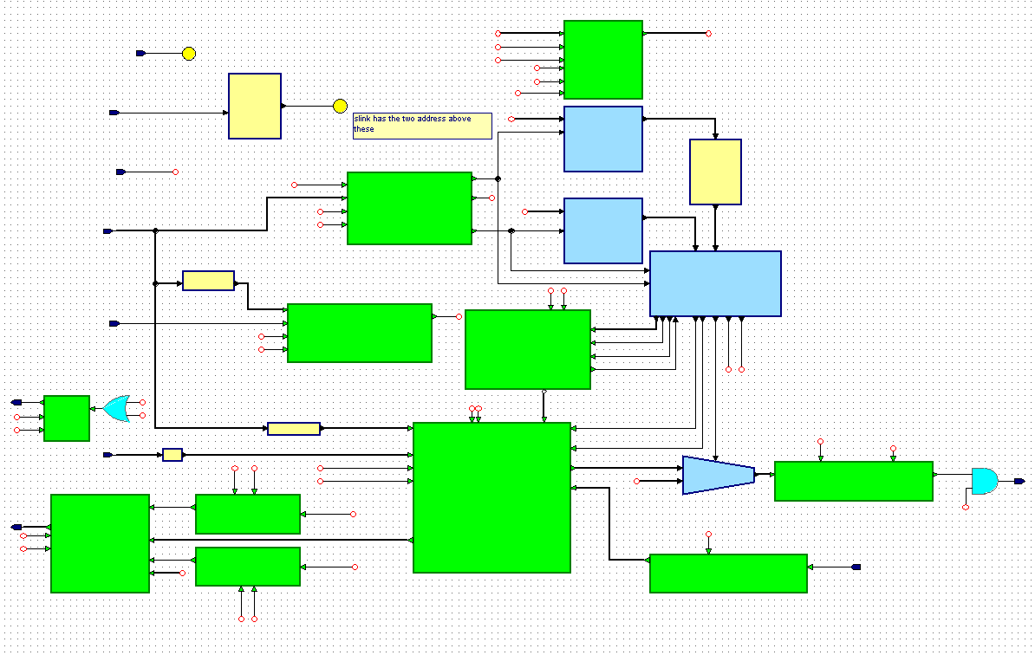
1)
2)
3)
4)
5)
6)
7)
8)
9)
10)
11)
12)

- Multiplexer to select data to be read back over VME. From RAM or from the serial status register. (port A)
- “Serial command and results” RAM. (Duel port. A = VME, B = serial)
- Address decoder for “Serial command and results” RAM.
- Address decoder for read command, write length and status registers.
- Address generator for serial side of RAM (port B)
- Status register for Serialiser. Tells VME if Serialiser is in use.
- Read command register. Stores the read command while it’s shifted out.
- Write length register. Holds the length of the write command.
- The FSM that controls the sequence of events.
- Asynchronous 32bit 2:1 multiplexer selects what to shift out over serial line.
- Parallel to serial converter. Makes 32bit command into serial stream.
- Serial to Parallel converter. Turns the returning serial stream back into 32bit wide data.

Again, the unlabeled blocks are ‘glue’ logic.

Structure of Vlink block

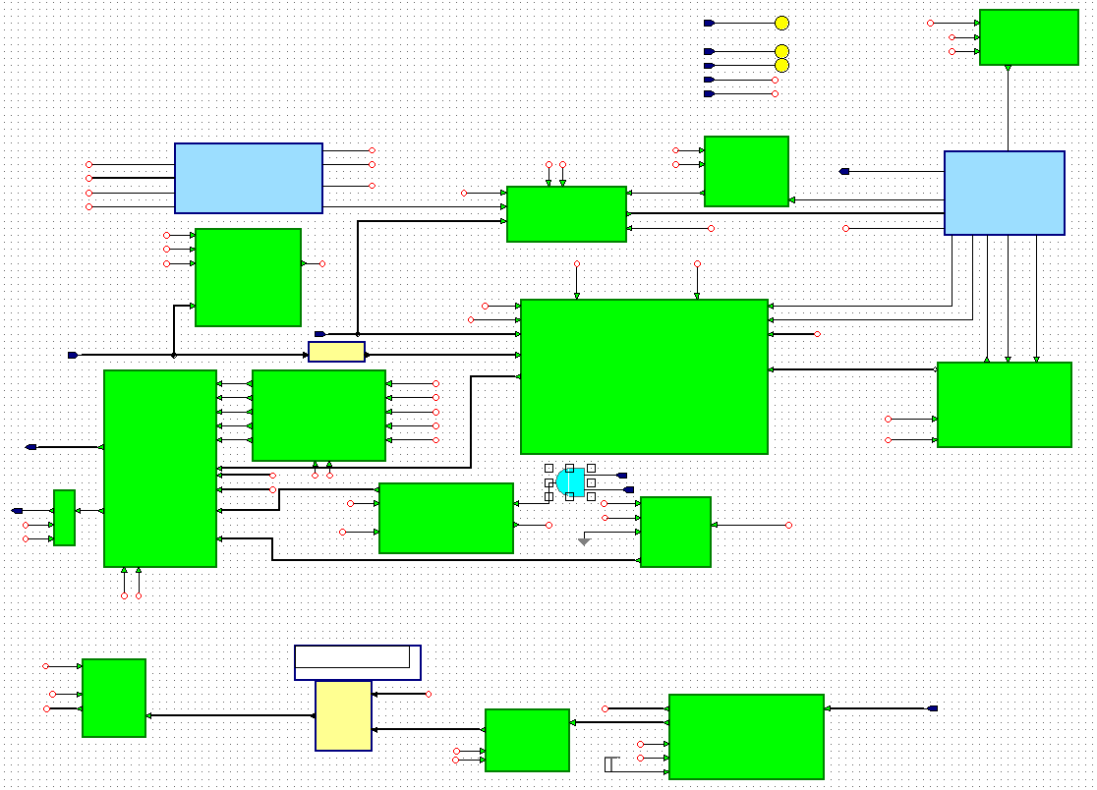
1)
2)
3)
4)
5)
6)
7)
8)
9)
10)
11)
12)
13)
14)

- Address decoder for frame_count, frame_length, Amount_RAM and for event ready/last.
- Address decoder for the Vlink data RAM.
- Read back data multiplexer to decide witch data to send back over VME.
- Read delay. Delays the read strobes to keep timing.
- Frame counter. Keeps count of the frame number.
- Vlink RAM. Stores incoming data before its read out over VME (duel port A = VME, B = Slink)
- Ready last register. Is the flag to hold off and restart data transfer from the BE chip.
- Make twice the size. Converts the set flag command from 80Mhz to 40Mhz domains.
- Vlink control. FSM that sequences the Vlink blocks to control them.
- Address generator. Creates the address’s for the Slink side of the RAM. (port B) Also provides the data stored in RAM value.
- Length counter. Keeps track of the event length.
- Write delay. Delays the write strobes to keep timing.
- Delay_MSB. Re a lines the DDR data back into format.
- Input_DDR. The DDR input block.

Structure of management block

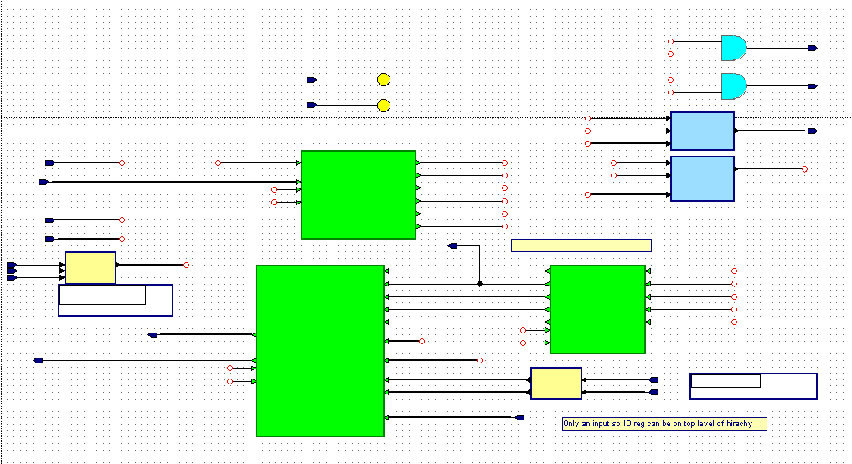
1)
2)
3)
4)
5)
6)

- Read back data select multiplexer. Selects what data is to be read back over VME.
- Address decoder. Decodes address’s for clock select, firmware ID, software RST and DCM RST, status register and TTC and BP count’s.
- Delay read strobes. Keeps timing.
- Status register.
- Clock select register. Stores the requested clock selection.
- AND gates. Because the address decoder produces a pulse on a read or a write, the resets would be active on a read or a write. To make them only active on a write they are AND’ed with the write strobe.

Register map: -

