CALICE
Charge collection and layout optimization
Simulations plan

The following brief notes underline the envisaged simulations plan for analysis and layout optimization of MAPS for CALICE.
It essentially consists of three phases:
- simulation or emulation of device fabrication process;
- analytical definition of particles event upset;
- simulation of electrical effects of particles event upset on defined device.

In more details:

- Simulation or emulation of device fabrication process.
Technology information (i.e. doping levels and profiles) or alternatively fabrication process information (i.e. individual fabrication steps, like implantation, deposition, annealing etc.) are needed to correctly emulate/simulate the fabrication process of the device. Access to this information should be agreed over with the foundry.

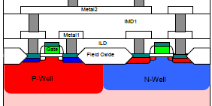
Fig.1. Process information is the first step
towards reliable and accurate simulation

- Analytical definition of particles event upset.
To simulate the effect of a SEU (Single Event Upset) , knowledge of initial charge distribution within the device is needed.
    - What can be done with DESSIS (semiconductor simulator) is to solve the transport equations of carriers once the initial and boundary conditions are known: i.e. biasing conditions (voltages/currents applied to the contacts and to the whole device) and initial charge distribution (i.e. 3D charge distribution within the device at t = 0⁺, namely after thermalization of electrons generated by the charged particle hit). This initial charge distribution has to be known with some accuracy for the transient simulation to be reliable. In principle any complicated 3D distribution could be incorporated into DESSIS: in practice it may be enough to define it only at some sampled points and interpolate.
    - If it is possible to obtain through Geant simulation a plot of Dose vs. distance from hit track for each of the simulated particle events (e.g. like in figure 3), this dose can then be translated into generated charge vs. distance in Si. The average dose would give a good indication of average generated charge, provided Auger generation (δ rays) is not too remarkable.

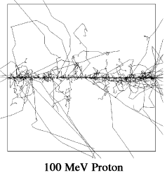
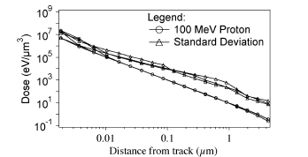

Fig.3. Example of Geant simulation of 1000 events in Si for 100 MeV protons
and related dose plot vs. distance from track

- Simulation of electrical effects of particles event upset on defined device. Once the device is defined, with initial charge configuration, the transient simulation can start. For each of the possible layouts (i.e. different placements of the collecting diodes) an estimate of collected charge, collection time, charge spread etc. as a function of spatial coordinates and time can then be obtained.

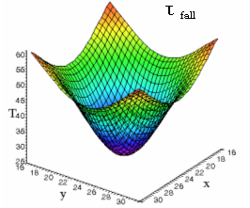
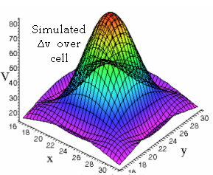
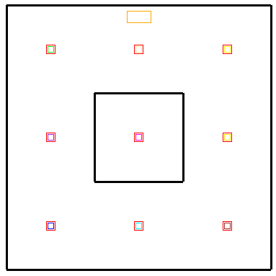
50μ
50μ

Fig.4. Example of layout simulation with corresponding collected charge and collection time

- The ‘optimum’ layout will require more than one collecting diode, placed according to some optimizing geometrical rule. For each of these geometrical solutions the same set of simulations will have to be carried out (fig.5).
- It is believed that collection time will not be an issue. The variable to be optimized will probably be the signal to noise ratio. Looking at the example picture above (fig.4), when the particle hits near the boundary of the cell, the collected charge by the cell may be rather low, unless a multi-diode solution is implemented. Under worst case condition (i.e. hit furthest from any collecting diode) the total collected charge should be above a minimum threshold, dictated by noise considerations.
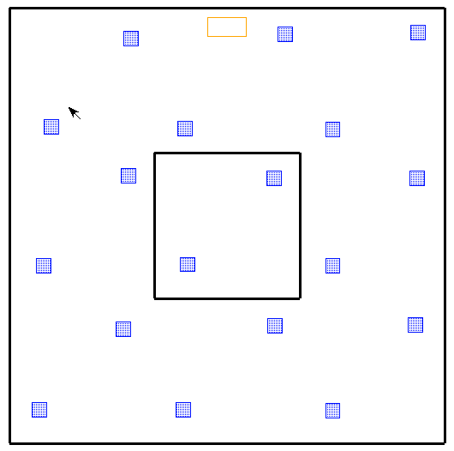
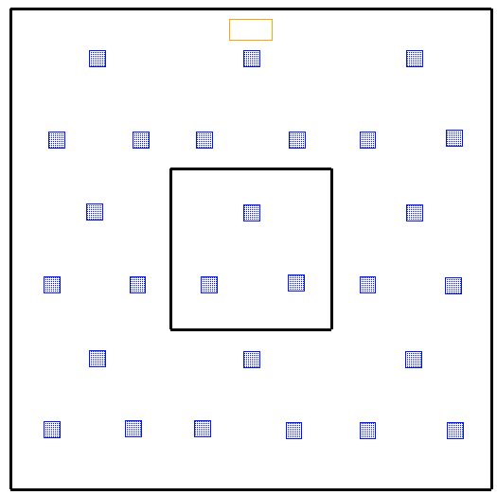

Fig.5 examples of possible layouts
Notes:
Process emulation
Device meshing
Accuracy check:
Q conservation
simulation time
‘Best’
tradeoff
Simulation layout i
Q map
T map
Data analysis
Layout i
i = i_{max} ?
i = i+1

Simulation process
end
<=1 week
(note 1)
<=2 weeks
(note 3)
Preparation
Layout i
(note 2)
Simulation plan flowchart
- This phase requires some iterations, in order to guarantee that the generated mesh of the device gives satisfactory simulation results (i.e. guaranteed charge conservation, reasonable simulation time required). For the structure under consideration, it is envisaged to be in the order of a 1 week.

- The i-th layout may require some accuracy checking as in the previous phase.

- Owing to the cell size, simulation of each layout, which will probably consists of an array of n x n cells, may be very time consuming. To build a reasonably approximated surface map of collected charge it is believed that up to 15 days are needed for each layout (but this will have to be checked and confirmed). This takes into account the time required to analyze the data and come up with the next, geometrically optimized layout.

The number of layouts is at this stage still unknown, as it is also dependent on other constraints (readout topology, design rules, etc). However, allowing say 3/4 months for this study, it might be possible to analyze layouts consisting of up to 10 collecting diodes (starting from an initial number higher than 1), a likely top limiting number.

Conclusions:

MAPS layout optimization in CALICE is complicated by the huge cell size. In order to guarantee a signal to noise ratio exceeding a minimum value throughout the surface a careful diodes layout has to be found out. Charge sharing will be inevitably present to an extent dependent on the layout chosen.
The estimated time for this study is in the order of three to four months, assuming full time simulation work.

□

