Problem Report Report Number: 5

Project Name: TeraPixel APS for CALICE

Item: Crosstalk/coupling effects

Problem
Crosstalk/coupling is observed when the whole sensor is enabled – this is generally evident in the threshold scan of pixels, which show a broadening of the threshold scan when other pixels are enabled.

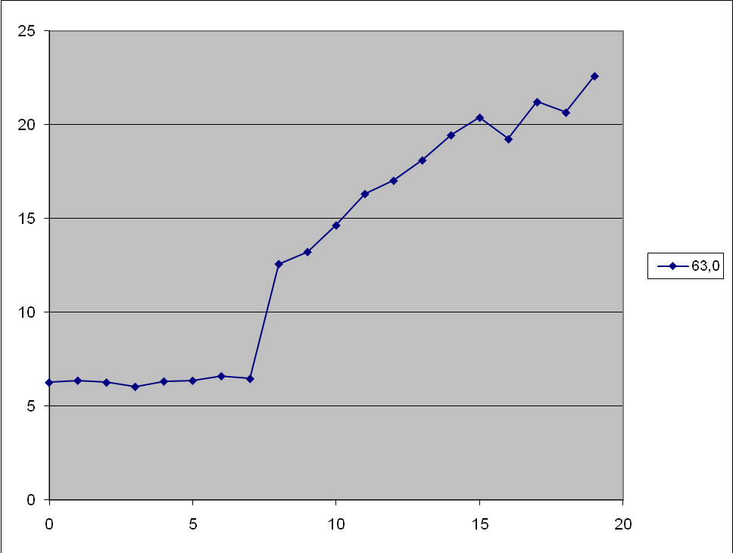

Plot shows (y axis) the RMS of the threshold scan of a single pixel (ie whether it is narrow or broad) versus the number of rows that are enabled (x axis). For each enabled row, 42 pixels become active; the location of the 42 enabled pixels each time is random, indicating the effect is global, not a local neighbour effect.

For this particular sensor the tripping point is between (7*42=294) and (8*42=336) active pixels, but it tends to vary somewhat between different sensors.

By shifting the trim of the pixel that we are interested in, it can be shown that the threshold scan of that pixel remains the same, but is burried under all the extra false hits caused by other pixels firing somewhere in the array.
Originator (Sign/Date)
Project Manager (Sign/Date)

Remedial Action
Evidence suggests this is a power loading problem, caused by lots of hits occurring in the sensor at the same time during the threshold scan (ie the lower end of the threshold range).

Note this is not the normal mode of operation, so for typical application use the coupling might not present any problems, as it is rare for >300 pixels to fire at once in ILC/cosmic/source/laser operation.

Suspect that the dominant current drain is due to monostables firing (which draw ~10uA each, so estimating the tripping current of ~3mA in a sensor region) . The monostables share a power net with one of the in-pixel comparators – when enough fire the droop in this power suppy is thought to cause comparators to “fire” in sympathy…..

Simulations below demonstrate that 200mV droop in VDD (and complimentary rise in VSS) can trigger an artificial “hit” output when the power net is changing potential - whether fast [5ns, left] or slow [3us, right] transient on power lines.

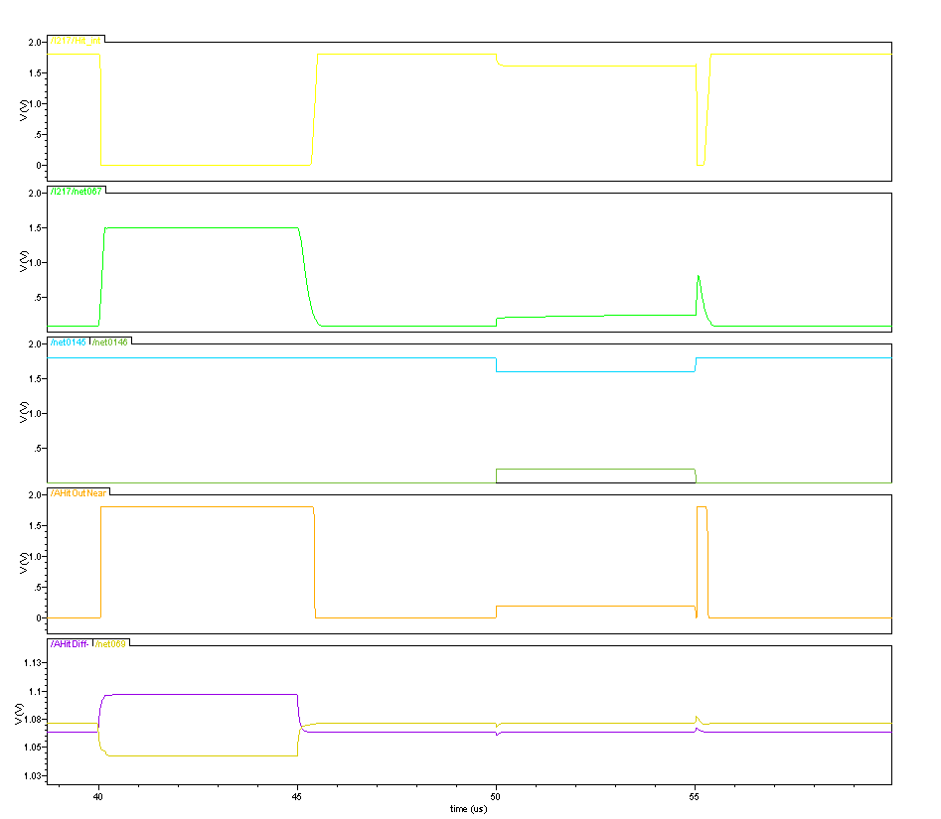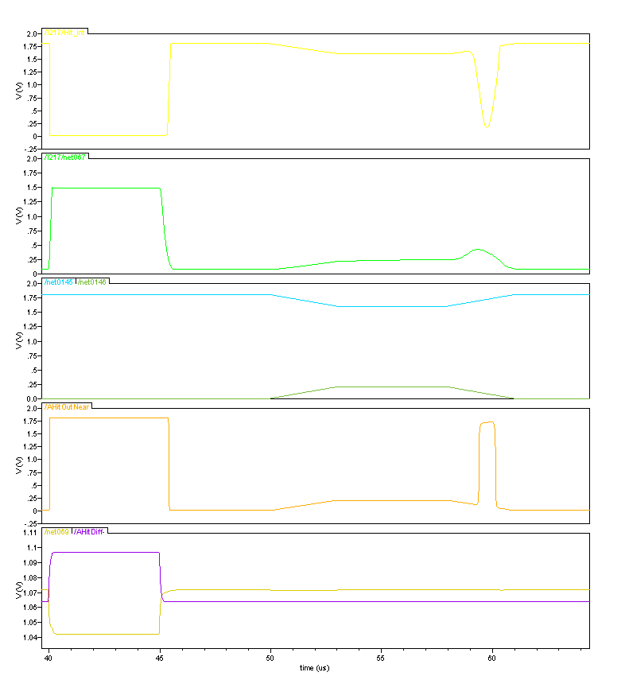

For TPAC1.1 & future revisions recommend VDD1V8dco is separated such that comparators have a dedicated power net, and the monostable power is separated such that this method for coupling is eliminated.

Project Manager (Sign/Date)

