Problem Report Report Number: 3

Project Name: TeraPixel APS for CALICE v1.1

Item: Comparator/Pixel oscillation at low threshold

Problem
Non-gaussian threshold scans were reported with very steep sides. Unusual comparator operation was also observed in the test pixels when very low thresholds were applied, resulting in oscillations: These are believed to explain the steep sides to the threshold scan.

Further investigation shows that positive feedback occurs for extremely small parasitic coupling between the comparator output and the diode node. When the threshold is sufficiently low this coupling results in natural oscillation.

Full RCX extraction and simulation confirms that the new pixel layout contains sufficient parasitic capacitance between the critical nodes to oscillate at low thresholds. Evaluating the important nets reports:

Original design: no parasitics reported between HIT (orange on layout) and DIODE (pale blue on layout)
New design: 30aF parasitic capacitance between HIT and DIODE

Sanity check: Can a 1.8v digital signal switching through 30aF cause problems?

Q=CV so Q = 1.8 * 30E-18 = 5.4E-17 = 337e- ~47mV signal …yes it can!

Note that any RCX simulation undertaken prior to submission was unlikely to find this problem due to the low threshold that must also be set to trigger an oscillation.

{see also: attached diagrams}

Originator (Sign/Date)

Non-gaussian threshold scan reported by PD at IC
Full analysis & interpretation of analogue testing: JC
Simulation & modelling: JC

Project Manager (Sign/Date)

Remedial Action
A modified pixel layout has been trialled that increases the shielding scope of M2 to better protect DIODE from HIT signal.

Revised design: no parasitic capacitance reported between HIT and DIODE.

This revision makes changes to M2 only so a possible single-mask change re-manufacture would be possible (foundry permitting).

Clearly any new design must treat the DIODE node with ultimate caution, particularly with regards any digital switching signal, but specifically the HIT node as it closes a positive feedback loop.

RCX simulation at low threshold is essential for any future design to pre-empt any similar effects.
Project Manager (Sign/Date)

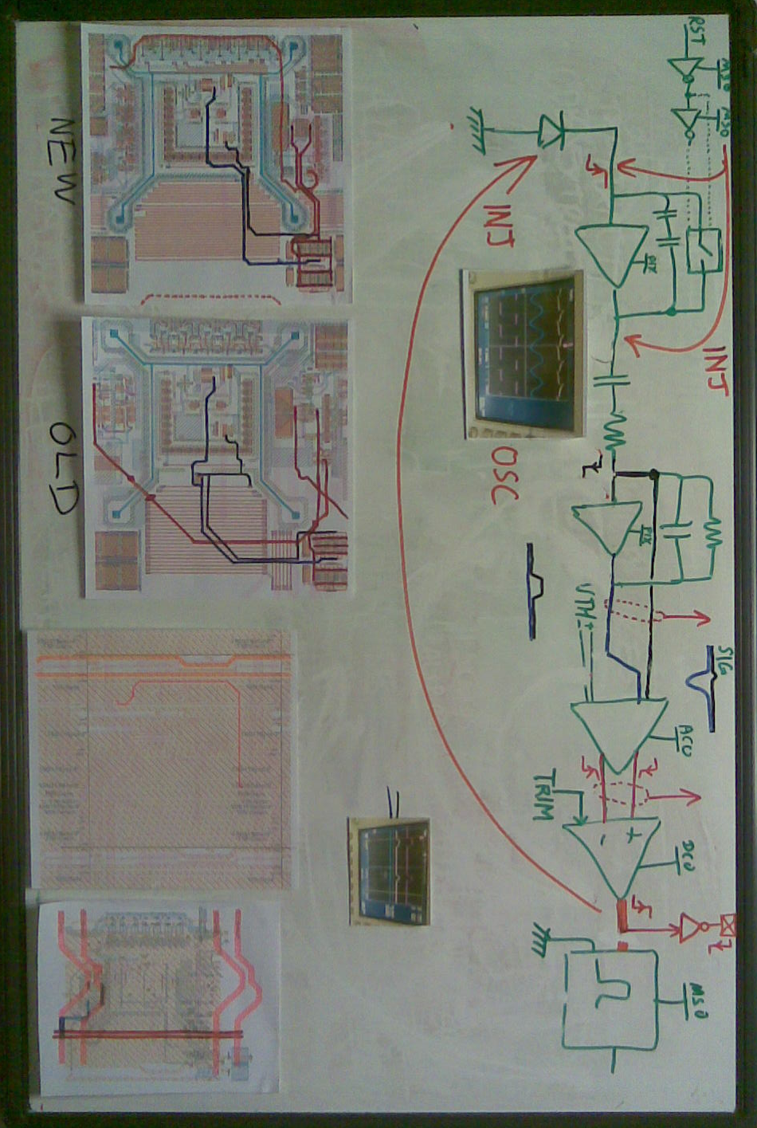
Note: “NEW” and “OLD” in this context refer to TPAC1.1 and TPAC1.0 respectively.

