Problem Report Report Number: 4

Project Name: TeraPixel APS for CALICE v1.1

Item: Injection from DEBUG_HIT_OUT onto DEBUG_RSTVAL1

Problem
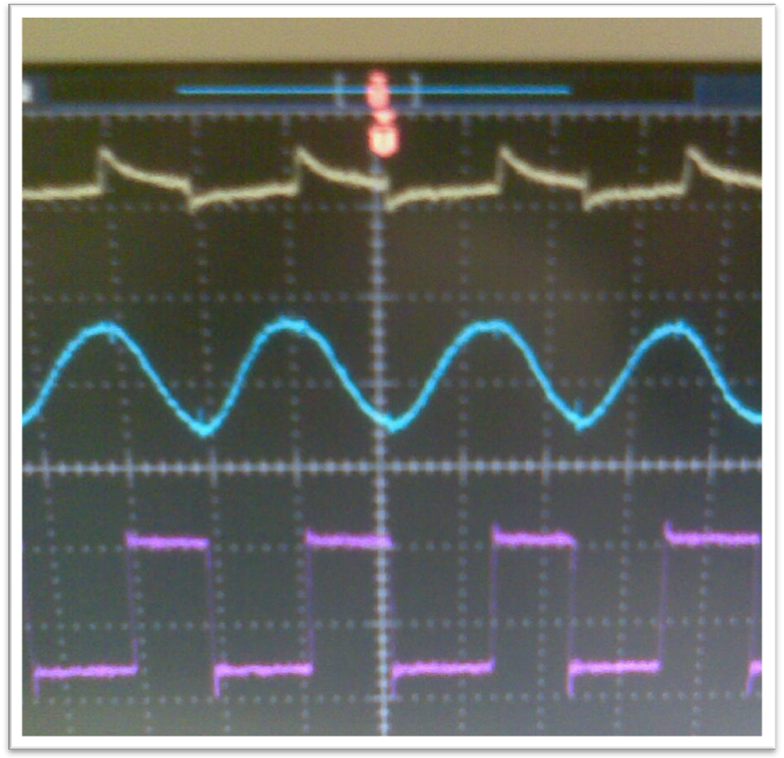
An injection of signal from the comparator to the shaper input signal in the test pixel is observed during analog test pixel investigations

A dependence on VDD1V8dig is seen in the magnitude of the injected signal on DEBUG_RSTVAL1 (yellow) and no effect on DEBUG_SIGVAL1 (blue)

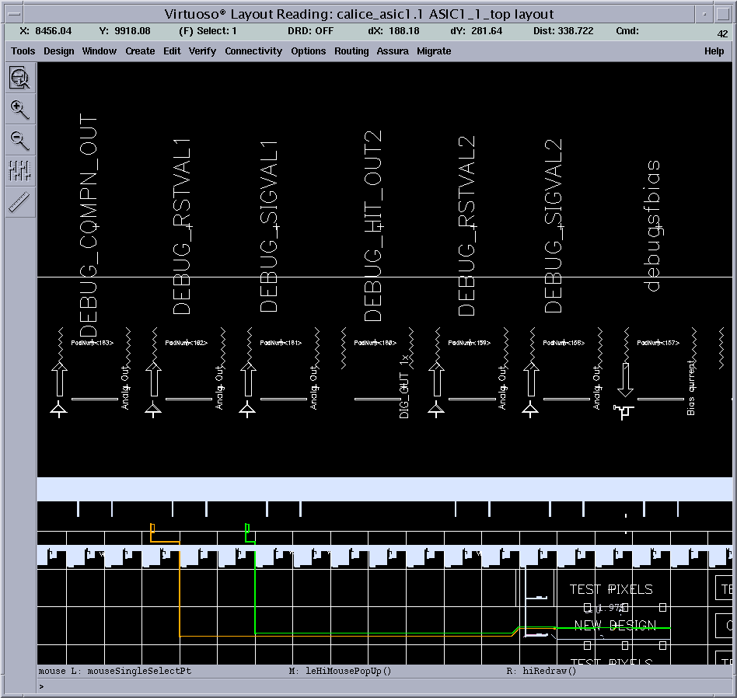

Investigation reveals this is NOT occurring in the pixel, but rather occurs in the line from in-pixel source-follower (for the analog signal) and digital buffer (for the digital HIT signal)
Originator (Sign/Date)

JC

Project Manager (Sign/Date)

JC
Remedial Action
Understanding of the problem is sufficient for operation of these test pixels.
No suggested action.
Be aware if re-spun, but unlikely to reoccur as is if scaled to a larger format sensor.
Project Manager (Sign/Date)

