Problem Report Report Number: 5

Project Name: TeraPixel APS for CALICE v1.1

Item: Configuration Registers: Power droop in buffer supplies

Problem
- Were reporting many errors and not holding the correct data
- Problem due to different power domains and high loading of “slow” clock drivers

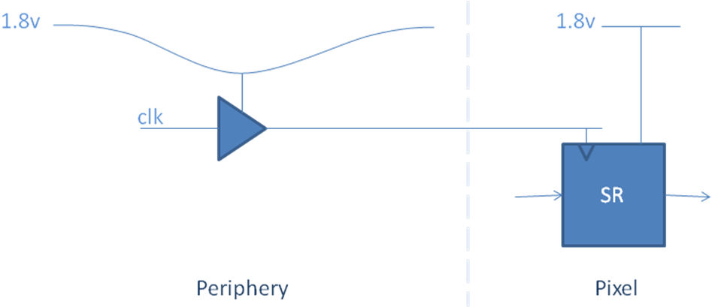
Originator (Sign/Date)

JC

Project Manager (Sign/Date)

Remedial Action
- Fixed by driving one of the power domains at 1.6v (previously 1.8v)
- Implemented using the power module developed for TPAC1.0 with updated resistor values and driving VDD1V8sram through J7
- Proved, reliable fix provided 2% tolerance on resistors on power module board.

Project Manager (Sign/Date)

JC

