Design and characterization of active pixel sensors in 0.25 CMOS
2004 IEEE Nuclear Science Symposium, Medical Imaging Conference, and Workshop of Room-Temperature Semiconductor Detectors

Abstract—We are developing CMOS monolithic active pixel sensors for High Energy Physics applications. We have successfully produced 3 test structures. They feature four different pixel types: the standard 3MOS, 4MOS allowing Correlated Double Sampling (CDS), charge amplifier pixels and a Flexible APS (FAPS). The FAPS has a 10 deep pipeline on each pixel. This is specifically designed with the beam structure of the TESLA proposal for the Linear Collider in mind.
P. P. Allport, G. Casse, A. Evans, R. Turchetta, J. J. Velthuis, G. Villani
A program to test our devices is well under way. Here results of a radiation test demonstrating that our devices are still operating well after a dose of 10¹⁴ p/cm² will be reported. Furthermore, the response of the FAPS to minimum ionizing particles from a ¹⁰⁶Ru β-source are presented. The obtained S/N-ratio for the 10 cells of the FAPS varies between (14.7±0.4) and (17.0±0.3).

INTRODUCTION
Usage of Monolithic Active Pixels as sensors to detect ionizing radiation is a recent and exciting development[1]. Active pixels have many highly attractive features: they can be very thin (~20μm), they are radiation hard (easily exceeding International Linear Collider demands and in the range for LHC applications), they yield good signal/noise when operated at room temperature and they offer the possibility of incorporating in-pixel intelligence makes them very interesting for HEP applications where data sparsification is an issue.
In the UK Active pixel collaboration we have successfully produced 3 test structures. The first structure, the RALHEPAPS 1, contains eight 8x8 pixel arrays. It was designed in th IBM 0.25 CMOS process. The pixels are 15x15 μm. The sensitive layer, the epi-layer, is only 2 μm thick. The four types that were studied are the standard 3MOS pixels, 3MOS containing 4 diodes per pixel instead of one, a 4MOS structure allowing Correlated Double Sampling (CDS) and a standard 3MOS with a calibration utility. The second device, RALHEPAPS 2, will be discussed in more detail in the next section. The third device, RALHEPAPS 3 was designed in TSMC 0.25 μm Mixed Mode Signal CMOS. This device does not have an epi-layer. Results on this device were reported in [1].

RALHEPAPS 2
The RALHEPAPS 2 is designed in the TSMC 0.25 μm CMOS Image Sensor technology. It contains 4 pixel types: standard 3MOS, 4MOS allowing CDS, a charge sensitive amplifier and the Flexible APS. Each pixel type comes in various flavors. It has an 8 μm thick epi-layer. The standard 3MOS and 4MOS substructures consist of 64x64 pixels with a 15 μm pitch. The FAPS substructures consist of 40x40 pixels with 20 μm pitch.
The 3MOS and 4MOS each come in 6 different flavors. The reference structure, the 3MOS A, has a 3x3 μm diode. The 3MOS B has a smaller diode size, 1.2x1.2 μm. The 3MOS C is like B, but with Gate-All-Around (GAA) transistors. The 3MOS D is like B but with the p-well as small as possible. The 3MOS E has four small diodes, 1.2x1.2 μm, in parallel. The 3MOS F is like E but with the p-well as small as possible. For the chips produced during the first submission, the 3MOS D and 3MOS F did not work. After resubmission, both structures are working fine. However, those chips arrived to late to include any results of the 3MOS D and 3MOS F in this paper.
The 4MOS A, B and C are the same with different values of the threshold voltage for the extra transistor. The 4MOS D, E and F are the same as A, B and C but with GAA transistors.

Source test
To measure the response of the devices to MIPs, the devices where illuminated using a ¹⁰⁶Ru β-source. The 4MOS pixels were readout like the 3MOS, so no CDS was used. Pedestals were calculated by averaging the signal for each pixel in all events after removing the hits. After pedestal subtraction a common mode correction was performed for each substructure in each event separately. The noise for each pixel was obtained as the standard deviation of the pixel signal after pedestal and common mode correction and removal of the hits. Next, cluster seeds were looked for. These are defined as pixels with a corrected signal larger than 8× its noise. These pixels are combined with neighboring pixels with a signal larger than 2× their noise into clusters. In Fig. 1 the random noise is plotted as a function of row and column number for the 3MOS A. Clearly, the noise is dominated by the column readout circuit. The cluster shape distribution is shown in Fig. 2 for the 7 substructures yielding clusters; the 3MOS F and 3MOS D did not work for chips of the first submission and the gain of the 4MOS GAA chips (D, E and F) was too low to see a MIP signal. The cluster signal distributions are shown in Fig. 3. Also listed are the most probable cluster signals for cluster of a maximum 3×3 size. The most probable signal is extracted by fitting a Landau distribution. The S/N is calculated by dividing the most probable signal by the average random noise of the substructure. The most probable signals, the noise and S/N are listed in Table I.
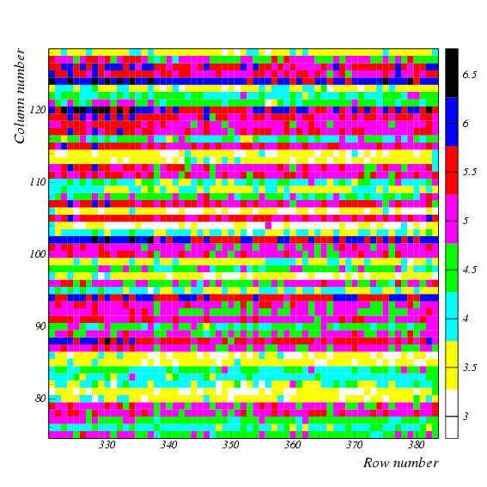
Fig. 1. Noise in ADC counts for the 3MOS A as a function of row and column number.
Table I
Overview of the signals, noise and signal/noise ratios for the various substructures.
Type |  | S | N | S/N
3MOS E | 4 diodes | 99±1 | 4.94±0.02 | 20.1±0.3
3MOS C | GAA | 87±2 | 4.85±0.02 | 18.0±0.4
3MOS B | 1.2×1.2 μm diode | 92±1 | 3.87±0.01 | 23.8±0.2
3MOS A | 3×3 μm diode | 67±1 | 3.31±0.01 | 20.3±0.3
4MOS C | Lower TX V_{T} | 101±2 | 4.14±0.02 | 24.4±0.4
4MOS B | Higher TX V_{T} | 114±2 | 4.70±0.02 | 24.2±0.4
4MOS A | Reference | 111±2 | 4.45±0.02 | 25.0±0.4

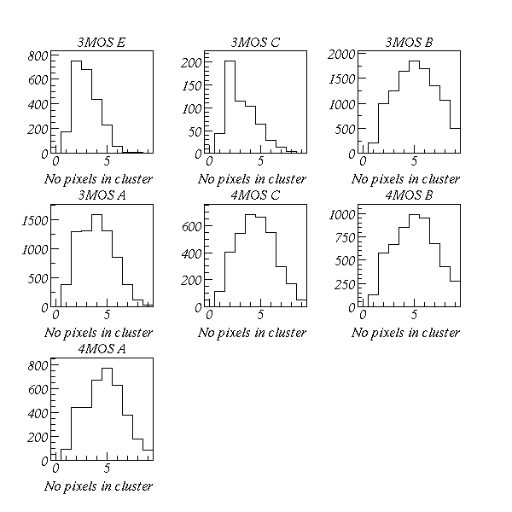
Fig. 2. Number of pixels in a cluster of maximum 3×3 size.

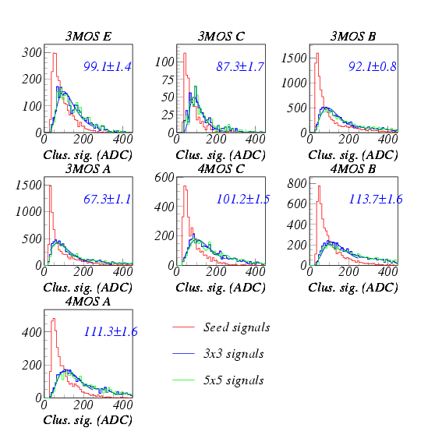
Fig. 3. Cluster signal distributions for seed pixels, 3×3 and 5×5 clusters. Also shown is the most probable signal for the 3×3 clusters obtained using a Landau fit.

Radiation test
Twenty four RALHEPAPS 2 devices were irradiated using the SPS at CERN up to 10¹⁵ p/cm². The maximum dose corresponds to half the integrated radiation dose that the ATLAS pixel detectors will have to withstand during the planned LHC data taking period. The requirement for the ILC is 10¹² p/cm². In Table II an overview is given of the number of irradiated chips per dose.
Table II
Overview of used doses and number of devices
Dose (p/cm²) | Number of chips
0 | 3
1x10¹¹ | 4
1x10¹² | 4
1x10¹³ | 4
5x10¹³ | 4
1x10¹⁴ | 2
2x10¹⁴ | 2
5x10¹⁴ | 2
1x10¹⁵ | 2

The devices were not clocked during irradiation. After irradiation the samples were kept and tested at -20°C. To measure the S/N ratio, the devices were inserted into the β-source set-up. The analysis discussed in section III was repeated using the same cuts. The noise and signal as a function of dose are shown in Fig. 4 and Fig. 5. In Fig. 6 the S/N ratio is shown as a function of dose. The plot demonstrates that the devices are still working reasonably well after 10¹⁴ p/cm².

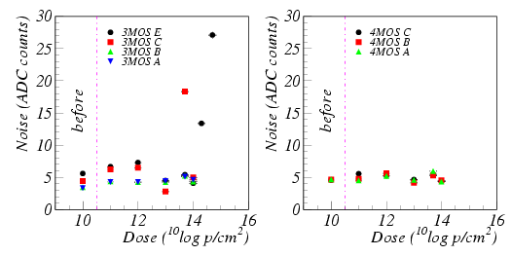
Fig. 4. Random noise as a function of radiation dose. The substructures operate well up to 10¹⁴ p/cm².
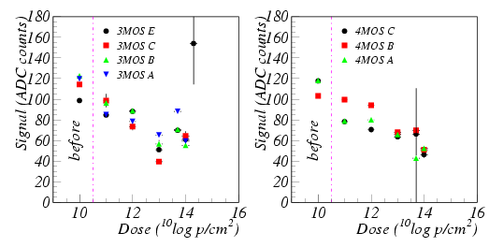
Fig. 5. Signal as a function of radiation dose. The substructures seem to operate well up to10¹⁴ p/cm².

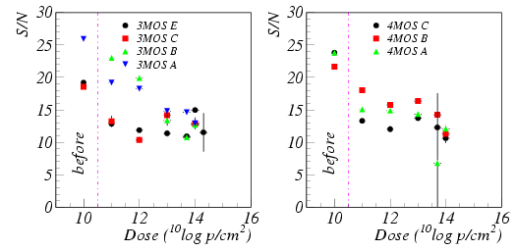
Fig. 6. Signal/noise ratio of the RALHEPAPS 2 as a function of the irradiation dose.

Leakage current
The leakage current was measured by placing the device in the dark and measuring the pedestal shift while varying the integration time. The integration time was varied between 6 and 200 μs. The slope of the pedestal versus time is a measure of the leakage current in ADC/sec. For each substructure the leakage current was plotted versus the dose. In Fig. 7 the leakage current is plotted as a function of the dose for the 3MOS E and the 3MOS A. Fitting a straight line yielded an increase in leakage current of ~1x10⁻¹⁴ ADC/ms×p/cm². Given the typical integration times used in our experiments, 10-100 μs, the pedestal only changes by less than 1 ADC count.
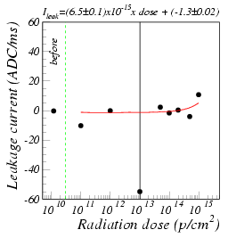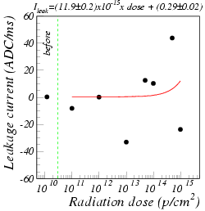
Fig. 7. Leakage current as a function of dose for the 3MOS E and the 3MOS A. No significant increease in l;eakage current with dose is observed.

Flexible APS
The Flexible APS (FAPS) has a 10 deep pipeline on each pixel. This design was developed with the TESLA proposal for the Linear Collider in mind. It allows fast sampling during the pulse train and the readout to take place in between the pulse trains. The FAPS is implemented in 5 different flavors. Each flavor consists of 40×40 pixels of 20×20 μm. Here only results of the FAPS B will be presented. The FAPS B has a 1.2×1.2 μm diode.

FAPS source test
The same β-source set-up was used to test the FAPS. The 10 memory cells were readout sequentially. The set-up was left free running. The signal of the first memory cell, cell 1, was subtracted from the signals of the other cells resulting in offline Correlated Double Sampling. After correcting the data for remaining common mode and pedestals, clusters were looked for in the same way as done for the other substructures. The cluster cuts used were 8× its noise for the seed and 2× their noise for neighbors. Hit finding was done for each memory cell separately. The cluster signal distributions for all 10 memory cells are shown in Fig. 8. Note that a hit found in memory cell i should also be present in cell i+1, hence the difference in statistics. The S/N of the cells 2 until 10 varies between (14.7±0.4) and (17.0±0.3).
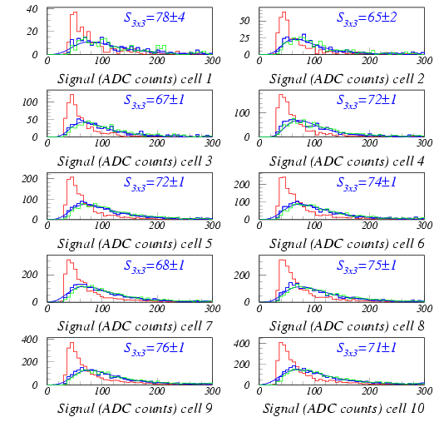
Fig. 8. Cluster signal distributions for the seed, 3×3 and 5×5 clusters for all 10 memory cells. Also listed is the most probable signal of the 3×3 clusters. Note that a hit found in cell i should also be found in cell i+1, hence the differences in statistics.

Hit resolution
Since a hit found in cell i should also be measured in cell i+1, two questions arise: how uniform is the response of the different cells and what is the efficiency of a hit. To address the first question, a parameter has to be found that provides a good measurement of the uniformity. This was done by studying the reconstructed hit position for the same hit in the different memory cells. Note that this is NOT the same as the position resolution. Hits were selected that were observed in all cells starting with cell 2. The hit positions were reconstructed using the Centre-of-Gravity method. For every hit the reconstructed positions were averaged over all cells excluding the memory cell under test. The difference between the reconstructed position in the cell under test and the average x and y positions was stored. The hit resolution was obtained by fitting these residual distributions and averaging the x and y resolution. The results are shown in Fig. 9, where the resolution is plotted as a function of memory cell number. The hit resolution is approximately 13 μm.
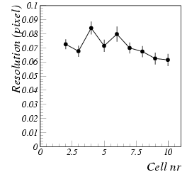
Fig. 9. Hit resolution as a function of memory cell number.

Efficiency estimate
To measure the hit finding efficiency, hits were selected that occurred in cell 2 and at least 6 other cells and yielded the same reconstructed hit position. In case a hit was not found in a memory cell, the maximum S/N of a single pixel in a 3×3 area around the expected hit location was stored. The result is shown in Fig. 10. Sometimes the hit is not found because there is another hit observed in the same memory frame. This causes S/N values larger than the seed cut of 8× the pixel’s noise. The inefficiency can be estimated by dividing the number of entries with a S/N less then the seed cut by the number of seeds in cell i-1. With the high seed cut of 8× the pixel noise, many hits are not found because the threshold is just not reached. However, when the seed cut is lowered to 5× the pixels noise, the obtained inefficiency varies between (0.08±0.08)% and (0.5±0.1) % depending on the cell number.
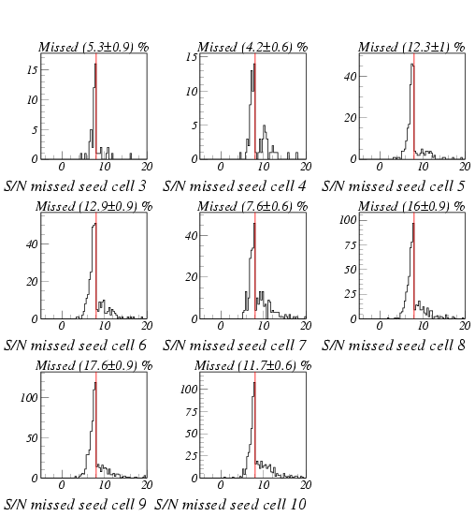
Fig. 10. Maximum S/N of single pixels in the 33 area around the expected hit.

Conclusions
We have successfully produced three active pixel test structures in 0.25 μm CMOS. Here the results of the RALHEPAPS 2 were presented. Out of the 12 3MOS and 4MOS substructures 7 yield a good S/N in source tests. The S/N varies between 18 and 25. Two substructures, 3MOS F and 3MOS D had initial fabrication problems. Those problems are solved after resubmission, but the chips arrived too late to report any results. The three 4MOS GAA substructures had too low gain to yield a MIP signal.
An irradiation program of the RALHEPAPS was performed. Devices were irradiated up to 1×10¹⁵ p/cm². The devices were still operating reasonably well after 1×10¹⁴ p/cm². The 3MOS E, which had 4 diodes in parallel, was the only device still showing hits above this dose.
The dependence of the leakage current on the radiation dose was studied. No significant increase in the leakage current was observed.

The first source measurements using the Flexible APS were presented. The S/N for the memory cells varied between (14.7±0.4) and (17.0±0.3). The response uniformity was measured by studying the difference in reconstructed hit positions in the different memory cells. The hit resolution was found to be 13 μm. Note that this is NOT the same as the spatial resolution as would be measured in a testbeam environment. Also the hit finding efficiency was measured. With an appropriate seed cut, the inefficiency is smaller than 0.5%.

Outlook
In spring 2005 a testbeam program will be started to measure the sensors efficiency and spatial resolution. Furthermore, a new large scale device, the RALHEPAPS 4, will become available also in spring 2005. This device will have 750×400 pixels with a size of 15×15 μm. It is designed in TSMC 0.25 μm CMOS Image Sensor technology with in an epi-layer thickness of 8 μm. This device will be a first step towards a full scale demonstrator pixel for the vertex detector of the ILC.

References
- P. P. Allport, G. Casse, A. Evans, R. Turchetta, J. J. Velthuis, G. Villani, “CMOS sensors in 0.25 μm CMOS technology”, proceedings of Vertex2004 to be published in NIM A.

 Manuscript received October 4, 2004. (Write the date on which you submitted your paper for review.) P. P. Allport is with the University of Liverpool, Liverpool, United Kingdom (telephone: 0044-151-7943365, e-mail: allport@hep.ph.liv.ac.uk). G. Casse is with the University of Liverpool, Liverpool, United Kingdom (telephone:0044-151-7943399, e-mail: gcasse@hep.ph.liv.ac.uk). A. Evans with the University of Liverpool, Liverpool, United Kingdom (e-mail: evans@hep.ph.liv.ac.uk). R. Turchetta is with the Rutherford Appleton Laboratory, Didcot, United Kingdom (telephone: 0044-1235446633, e-mail: r.turchetta@rl.ac.uk). J. J. Velthuis is with the University of Liverpool, Liverpool, United Kingdom (telephone:0044-151-7943414, e-mail: jaap@hep.ph.liv.ac.uk). G. Villani is with the Rutherford Appleton Laboratory, Didcot, United Kingdom (telephone: 0044-1235445072, e-mail: g.villani@rl.ac.uk).

