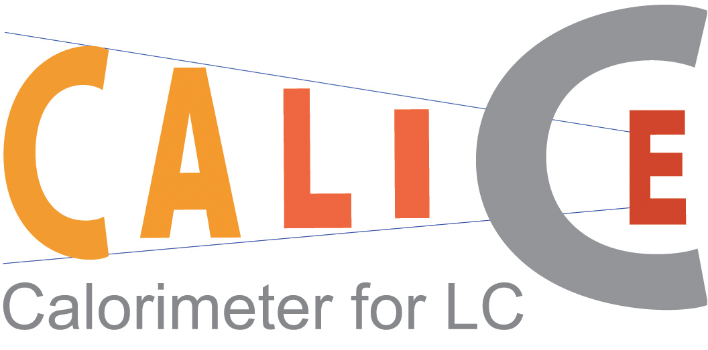

Memorandum of Agreement

between the members of the CALICE Collaboration

- Introduction
A future linear collider (LC) producing electron-positron interactions at a centre of mass energy between 90 GeV and around 1 TeV is globally recognized as the next major project of accelerator particle physics. The physics program, as well as the general environment of such a machine, requires the design of a new generation of detectors.

The R&D project PRC-DESY 02-01, which followed on from studies for the TESLA TDR, was used as a starting point to build up a collaboration, called CALICE (CAlorimeter for the LInear Collider with Electrons), to fulfil an R&D program into the design of the calorimetry for a LC. The goal is to have a well-established scientific and technical case ready so as to be able to write a proposal for calorimetry for a LC detector in a timely manner. The current paradigm requires calorimeters with fine segmentation and optimizes their design for the reconstruction of the energy and direction of all the individual particles in multi-jet events; the so-called “particle flow algorithm” technique.

For financial as well as scientific reasons, this optimization can only be done by considering the total overall calorimeter. Hence, the electromagnetic (ECAL) and hadronic (HCAL) calorimeters must be designed together and the R&D within CALICE covers both. These studies make use of detector simulations based on GEANT and dedicated reconstruction software. They are therefore dependent on assumptions about both the technical feasibility of the proposed detectors as well as the accuracy of the simulation to describe the shower development. This motivates the construction of prototypes for both the ECAL and HCAL to verify these assumptions.

This effort is now under way within the CALICE collaboration, which is now relatively large with about 28 institutes as members. However, the collaboration is open to potential new collaborating institutes. Because of its size, an organizational document will help the management of the collaboration and improve its efficiency.

The purpose of this document is to provide such a structure and establish and organise the participation of the groups within CALICE. The internal rules and structure of the collaboration are presented in Annex 1.

- Collaborating parties and their representatives
The following groups are involved in this project and constitute the collaboration.

Country | Laboratories | Under the authority of
Czech Republic | Institute of Physics – Academy of Science, CR  Charles University | Dean of Univ. Dept.  IOP director
France | Laboratoire de Physique Corpusculaire – Clermont  Laboratoire de l’accélérateur linéaire – Orsay  Laboratoire Leprince Ringuet – Palaiseau  Physique des Interfaces et Couches Minces – Palaiseau | IN2P3/CNRS
Germany | DESY – Hamburg  Hamburg University | DESY
Korea | Kangnung National University  Seoul National University | MOST ? KNU
Russia | Institute of Theoretical and Experimental Physics – Moscow  Lebedev Physics Institute – Moscow  Moscow Engineering and Physics Institute – Moscow  Institute of Nuclear Physics - Moscow State University  Institute of High Energy Physics – Protvino | ????
United Kingdom | School of Physics and Astronomy – University of Birmingham  Cavendish Laboratory – Cambridge University  Department of Physics – Imperial College London  Department of Physics and Astronomy – University College London  Department of Physics and Astronomy – University of Manchester  Rutherford Appleton Laboratory – Didcot | PPARC
United States of  America | Argonne National Laboratory – Argonne  Department of Physics – University of Texas at Arlington  Northern Illinois Center for Accelerator and Detector Development, North Illinois University – Batavia | ANL director,  Dean of Univ. Depts
International | Joint Institute for Nuclear Research – Dubna | JINR director
Table 1: Laboratories and Authorities involved in the collaboration

- Scope of this Memorandum of Agreement
This document describes the CALICE collaboration as well as its goals and plans. It lists the responsibilities taken on by collaborating groups. With regard to the schedule and collaboration goals, it supersedes the PRC-DESY proposal PRC 02-01.

- Project description
The goal of the collaboration is to design and propose a fully-specified calorimeter for a LC detector. This will be based on the technology R&D and test beam results produced by the collaboration. To fulfil this goal, several different prototypes are under design and construction.

Currently (early 2004), several prototypes are under design and construction in the collaboration. The ECAL is made of silicon tungsten. There are several HCALs, one based on scintillating tiles with analogue readout (the analogue HCAL) while the others have very small pad sizes and single bit readout (the digital HCALs). The work and responsibilities of the groups are given in table 2. The major goal of the collaboration is to have prototypes for each device ready for test beam with electrons and hadrons in 2005 or early 2006.

ITEMS | Involved laboratories
ECAL prototype
General mechanics | LLR, LAL
Silicon wafers processing | IOP-ASCR, MSU
VFE chip | LAL
Special DAQ | LLR
Prototype DAQ | Imperial, Manchester, RAL, UCL
ECAL R&D for final design
PCB, cooling, DAQ | KNU, SNU, LLR, LAL
VFE | LAL, LPC
Silicon wafers and related | IOP-ASCR, LLR, PICM
Tile HCAL Prototype
General | DESY, Hamburg, ITEP, IOP-Prague
Photodetector | ITEP, MEPHI, IOP-Prague
VFE | JINR-Dubna, IOP-Prague
DAQ
Digital HCAL Prototype
General design | ANL, IHEP-Protvino, Texas–Arlington
RPC design | ANL, IHEP-Protvino
VFE, readout and DAQ | ANL (with help of FNAL), DUBNA, Minsk,
GEM development | Texas-Arlington
General
Tail catcher | NICADD-NIU
HCAL prototype mechanics | DESY
Simulation and other software services | DESY, LLR, NICADD-NIU, Birmingham, Cambridge, Imperial
Table 2: Groups involvement in the prototype and R&D work

The funding and the manpower involved in the project for 2003 are summarized in Annex 2. It gives a representative snapshot of the level and division of the effort and investment made by the different groups.

- Test beam requirements
The requirements for a test beam program have been defined. It includes both electrons and hadrons, from low energy (about few GeV) up to about 50 GeV, which covers the range of energies most commonly found in hadronic jets at a LC. The first test beam, with only the ECAL, is foreseen for late in 2004 at DESY with a low energy (around 6 GeV) electron beam. The general test beam “season” will use the ECAL and both HCAL prototypes together in beams of hadrons and high energy electrons and will be in 2005-2006. During this general test beam period, the silicon-tungsten ECAL will be located in front of both HCAL options, in order to give real measure of the capability for comparison with the simulation. Using both HCAL options will allow a comparison of the quality and performance of both.

The groups involved in the R&D and construction for each subdetector have the responsibilities to design, fund and build the prototypes to be ready on this timescale. Each group participating in the detector construction will have responsibility for travel, contingency funding and providing a detector which meets the required performance. A document will be signed between the laboratory owner of the beam structure and the CALICE Steering Board, establishing an agreement for the test beam period.

- Modifications, disagreement and effective date
This MoA will be effective up to the end of 2006, beyond the last test beam data period. If needed, an extension could be signed to extend the duration of the MoA. Any such modifications or additions shall require approval as formal amendments to the MoA.

SIGNATURES HERE

ANNEX 1

The internal rules and structure of the collaboration

The organization
The CALICE collaboration is organised around a steering board (SB) representing the different countries involved in the project. The SB has the charge of organizing the R&D and construction of the prototypes. In addition, each subdetector has a project leader, who is responsible for ensuring the subdetector will ready for test beam at a date as close as possible to the summer of 2005. The project leaders form the technical board (TB).

The Steering Board.
The SB represents the collaboration and is in charge of the everyday life of the collaboration, including external representation.

The SB has been designed by the group leaders involved in the project and consists of the chair of the SB and the Spokesperson, both of whom are elected by the board members, and one representative for each country or major group, chosen by the collaboration members of that group. The chair of the SB organizes the meetings of the board, prepares the agenda of these meetings and chairs the sessions. At each meeting, the chairman will nominate a secretary to take the minutes of the meeting. The minutes are accessible to the collaboration members. A member can ask to the chairman for agreement to be replaced by a person of its choice for a SB meeting.

The SB will meet at least once a year, and at any time when a majority of the SB asks for it. Its charge concerns the scientific goals, the funding questions, the responsibilities, and any modification of the MoA. After discussion, decisions should be reached by general consensus whenever possible. The current (early 2004) members of the SB are:

J.-C. Brient (LLR) representing the ICFA-LC calorimeter working group,
M. Danilov (ITEP) representing the Russia collaborators,
P. Dauncey (Imperial) representing the United Kingdom collaborators,
G.B. Kim (KNU) representing Korea collaborators,
J. Repond(ANL) representing the United States of America collaborators,
F. Richard (LAL) representing the France collaborators,
F. Sefkow (DESY) representing the DESY collaborators,
V. Vrba (IOP-ASCR) representing the Czech collaborators,
R.D. Heuer (Hamburg) representing the World LC-Detector Steering Group.

At the first SB meeting, R.D. Heuer was elected chair of the SB and J.-C. Brient was elected the Spokesperson of the collaboration.

The Technical Board
The SB has the charge to organize the R&D and the construction of the prototype. However, in order to better structure the project, each subdetector has a project leader, responsible for all aspects of that project. The project leaders for the three prototypes under construction are currently (early 2004):

J.-C. Vanel (LLR) for the ECAL project,
V. Korbel (DESY) for the tile HCAL project,
J. Repond (ANL) for the digital HCAL project

New collaborators
Potential new collaborators asking to join the collaboration must produce a Letter of Intent (LoI) describing the proposed R&D project, the responsibilities to be taken, and the related funding and effort. This LoI must be signed by the group leader and the related funding agencies or authority (e.g. the head of the physics department for a university). It will be send to the SB members, who will then decide on the proposal. A new group will have to fund all the R&D they propose to do and, if there is a need for common funds, the SB will also negotiate agreement with new groups for their contribution to this fund.

If the new collaborating group is related to a funding agency not already represented, one person will be proposed as representing the group on the SB, following agreement between the new group, the new funding agencies and the SB.

Editorial and publication policy
The editorial policy applies to publications, conference presentations and proceedings. The policy applicable to any public presentation depends on the work being published as follows.

For presentations of basic R&D work performed within the CALICE framework, the author list should reflect the people involved but reference to CALICE is strongly recommended whenever possible.

The author list for results from early beam tests (e.g. the minical or ECAL-only tests) should be restricted to the groups involved; for example, the tile HCAL groups for the minical results. Special cases for people involved in more than one specific device, such as through simulation work, will be treated individually.

The test beam results involving both the ECAL and either of the HCALs will be treated as the collective property of the collaboration. The author list will therefore be the official collaboration list, established by the SB.

ANNEX 2

Funding and effort investment in 2003

During the year of 2003, the project has made a lot of progress with works and funding from the different laboratories. The following table displays the actual effort and funds used in the year.

 | Equipment funds (k€) | Travel funds  (k€) | Effort (FTE)

ECAL
ASCR – Czech republic  IOP, Charles Uni. | 10
IN2P3/CNRS – France  LAL, LLR, LPC, PICM | 100 | 30 | 12.5
MOST – Korea  KNU, SNU |  | Please fill | Please fill
RUSSIA groups  INP-MSU |  | Please fill | Please fill
PPARC – United Kingdom  Birmingham, Cambridge, Imperial, Manchester, RAL,  UCL | 90 | 20 | 8.0

Tile HCAL
ASCR – Czech republic  IOP, Charles Uni. | 10 | Please fill | Please fill
DESY – Germany  DESY Hamburg, Hamburg Uni. |  | Please fill | Please fill
RUSSIA groups  ITEP, MEPHI, LPI |  | Please fill | Please fill

Digital HCAL
DOE and NSF – USA  ANL, UTA, NIU +? |  | Please fill | Please fill
RUSSIA groups  IHEP, JINR, Minsk |  | Please fill | Please fill

