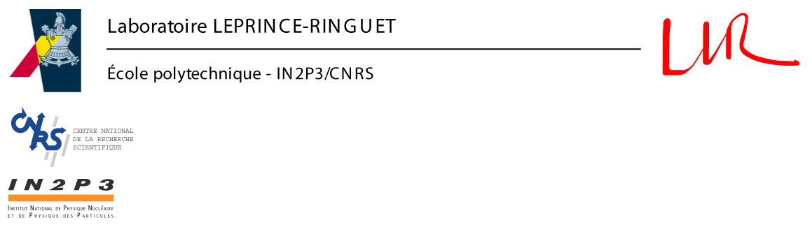
Palaiseau, 28th January

Dear PPRP Chair,

I am writing to you as CALICE Spokesperson in support of the UK CALICE proposal which I think your committee will consider at the next meeting.

Since the UK groups joined CALICE two years ago, they have had a large and very positive impact on the collaboration. They took responsibility for the ECAL readout electronics and DAQ system and have produced many important and interesting studies in the simulation area. It would be extremely difficult for CALICE if they were unable to continue this very fruitful collaboration.

Their proposal has been presented to the collaboration and also discussed informally several times. Besides the goals of taking data at several beam tests over the next few years and continuing the very nice work studying the simulations, I understand the proposal wants to start several new projects to build towards our eventual goal of a linear collider calorimeter. I am very happy this activity is taking place within the CALICE collaboration and I would encourage more such activities from other countries.

The UK projects are all in areas where R&D is very important. In the area of DAQ for calorimeters, the UK has identified several critical issues which need study and these must be developed soon for us to understand the best structure for the final DAQ. It is important this work is done in close collaboration with the CALICE work on the readout chip at Orsay and I am pleased this is explicitly stated as a goal of the work.

The mechanics studies have been discussed in detail with my own group at LLR/Ecole Polytechnique and the work here will complement our own studies very nicely. The group will bring effort to areas which we have no funding to study ourselves, although they are vital for designing a final mechanical support for the ECAL.

The digital pixel concept is quite new and so it is hard yet to know how well the idea will really work. However, the performance and cost may turn out to be superior and so I very much welcome this development. We have always wanted studies of different solutions within CALICE, so shown by the studies into both an analogue readout and a digital readout for the hadronic calorimeter. Making this also for the ECAL can only strengthen our collaboration. As the pixel idea has now been given to the linear collider community, it seems likely someone will develop this concept in the near future and I would be very disappointed if it was not done within the CALICE collaboration. The UK groups have the expertise to do this work and the results of these studies are essential for the design of the future ILC detector.

I hope this letter will add useful informations for your discussion and that you will be able to support the work proposed.

Regards,
Dr J.-C. Brient

Laboratoire Leprince-Ringuet - École polytechnique - F-91128 PALAISEAU cedex
Tél. secrétariat : (33) 1 69 33 41 36 - Télécopieur : (33) 1 69 33 30 02 - e-mail : secretariat@poly.in2p3.fr - http://polywww.in2p3.fr

