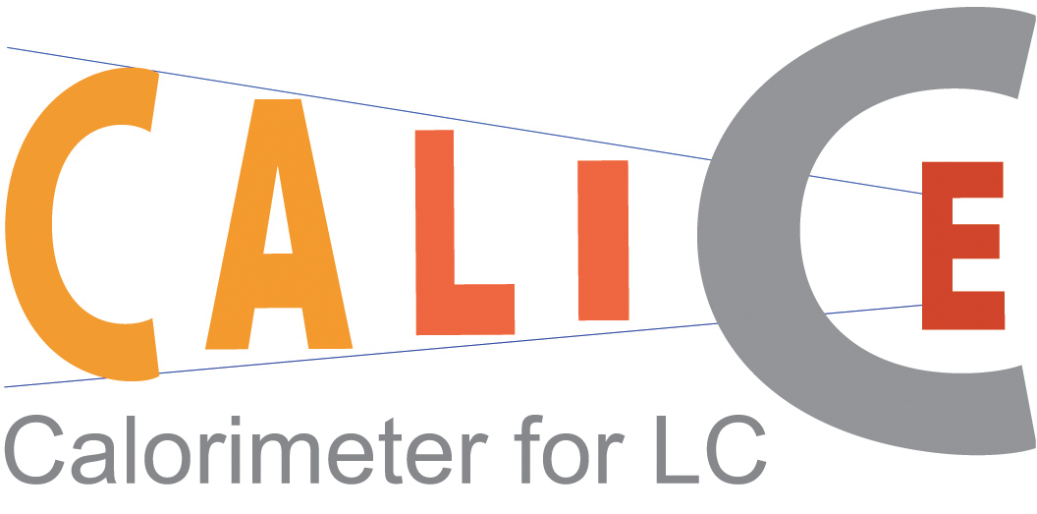

Internal rules and structure of the CALICE Collaboration

The organization
The CALICE collaboration is organised around a Steering Board (SB) representing the different countries involved in the project. The SB is charged with coordinating the R&D and the construction of the prototypes. In addition, each subdetector is lead by a project leader, with the responsibility to ensure the timely construction of the subdetectors. The project leaders form the Technical Board (TB).

The Steering Board.
The SB takes the major decisions concerning the collaboration. The SB consists of the Chair of the SB and the Spokesperson (both of whom are elected by the board members) and one representative of each country (who are appointed by the members of that country). Each country can decide how they wish to appoint their representative. The Chair organizes the meetings of the board, prepares the agenda of the meetings and chairs the sessions. At each meeting, the Chair appoints a secretary to take the minutes. The minutes are accessible to all members of the collaboration. For a given meeting, with the agreement of the Chair, members can designate a substitute to represent their country.

Meetings can be scheduled at any time provided a majority of the SB requests such a meeting. The SB should meet at least four times a year.

The SB is responsible for defining the scientific goals, resolving issues concerning the collaboration, and considering suggestions for modifications of this document. Decisions are taken by general consensus as far as possible. At the first SB meeting, J.-C. Brient was elected Spokesperson of the collaboration. The current (end 2004) members of the SB are:

J. Repond (ANL), Chair,
J.-C. Brient (LLR), Spokesperson,
M. Danilov (ITEP), representing the Russian groups,
P. Dauncey (Imperial), representing the United Kingdom groups,
D.W. Kim (KNU), representing Korea groups,
A. White (UTA), representing the United States of America groups,
F. Richard (LAL), representing the France groups,
F. Sefkow (DESY), representing the German groups,
V. Vrba (IOP-ASCR), representing the Czech groups.

The term for the Spokesperson will be for the length of the current project. The term for the Chair is for two years.

The Technical Board
The TB is chaired by a Technical Coordinator appointed by the SB. In addition, the TB consists of a deputy coordinator, the project leaders of the subprojects within CALICE and other experts as appointed by the SB or TB. The project leaders of the subdetectors are responsible for all aspects of that project.
The TB should meet frequently, around once a month. As of the end of 2004, the coordinator of the technical board is Jaehoon Yu (UTA) and the deputy is still to be appointed. The other members of the technical board are (end 2004):

J.-C. Vanel (LLR) for the ECAL project,
V. Korbel (DESY) and F. Sefkow (DESY) for the tile HCAL project,
J. Repond (ANL) for the digital HCAL project,
P. Dauncey (Imperial) for DAQ,
D.Ward (Cambridge) for the software project.

New collaborators
New collaborators asking to join the collaboration must produce a Letter of Intent (LoI) describing the proposed R&D project, the responsibilities they plan to take, and the projected funding and effort. The LoI must be signed by the group leader and the relevant funding agencies or authority (e.g. the head of the physics department for a university). It will be sent to the SB members, who will then decide on the proposal. The new group is expected to fund its entire proposed R&D.

If the new group is from a country not yet present in the collaboration, one person will be appointed to the SB as the representative of this country.

Editorial and publication policy
The editorial policy applies to publications, major conference presentations and the resulting proceedings. The policy applicable to these public presentations depends on the nature of the material being published and the importance of the conference, if applicable.

- For presentations of basic R&D work performed within the CALICE framework, the people directly involved with the project should determine the author list. In addition, reference to CALICE is strongly recommended.
- The author list for results from early beam tests (e.g. the Minical or ECAL-only tests) should be restricted to the groups involved in the tests; for example, the tile HCAL groups for the Minical results. The SB will decide on special cases, such as people working on common aspects like electronics, simulation, software, etc.
- The test beam results involving both the ECAL and either of the HCALs will be treated as the collective property of the collaboration. The author list will therefore be the official collaboration list, as established by the SB.

A Speakers Bureau will be established to coordinate abstract submissions to conferences, decide on speakers, and organise approval of results, to be shown. The Bureau will consist of four members; the Chair, the Deputy Chair, the Collaboration Spokesperson and the Steering Board Chair.

Each member of the collaboration has the right to comment on the drafts of journal publications and major conference talks (and their resulting proceedings). In case of irreconcilable disagreements between members of the collaboration, the SB will decide on the final wording.

For minor conferences, consultation with other members of the collaboration is strongly encouraged, but the final responsibility for the presentation and proceedings lies with the person giving the talk.

