***CALICE IV***
Simulation results

Simulation data results for CALICE 4 Diodes layout, 25 μm cell pitch.

Collecting diodes layout:
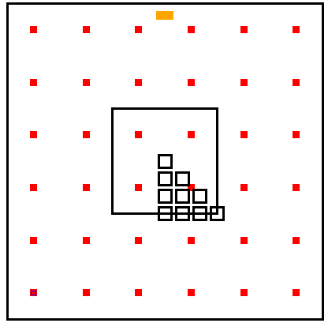
Cell size: 25 x 25 μm²
Cell 9
Cell 8
Cell 7

Diode size: 1.5 x 1.5 μm²

Epitaxial thickness: 20 μm
Cell 4
Cell 5
Cell 6
1

Diode location: S4
3
4
Cell 1
Cell 2
Cell 3

10 Hit points
1
2

Diode bias: 2V
PWell bias: 0V
Substrate bias: floating

Ten hit points have been simulated, corresponding to the center of the small squares in the picture above (in the central ‘cell’), numbered as follows:

1
2
3
4
5
6
7
8
9
10

N.B. To speed up the simulations, a coarser mesh has been used: this should imply an absolute accuracy in collected charge not worse than 20%. More refined simulations will be carried out soon.
The definition of a cell is somewhat ambiguous in this case, as the diodes are not logically grouped, either because of geometry or electrically: however, in this context and in the data representation chosen, each ‘cell’ is defined as a group of 4 diodes enclosed by a square as in the picture above. Within each cell, each diode is numbered anticlockwise, from the ‘bottom left’ (again see picture above).

Data results for each of the diodes of each ‘cell’ for each of the hits are reported below.
Owing to the symmetry, it is easy to mirror the results over the whole 3 x 3 cells area: some examples are reported below. From these data, it should then be possible to come up with an approximated function that describes for example the total collected charge (i.e. the sum) from the 4 diodes of a cell as a function of the spatial coordinates of the hit over the whole area ( 3x3 cells in this case).

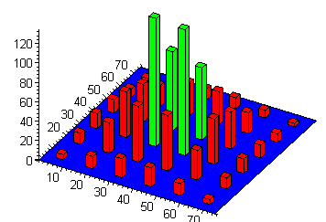
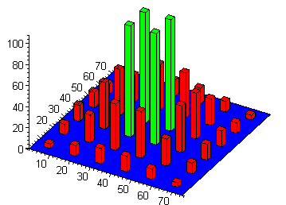
1
2
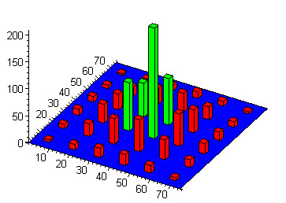

Diodes Collected charge
hits 1,2,3

3

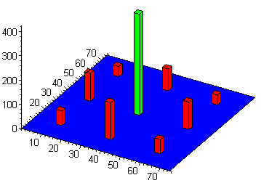
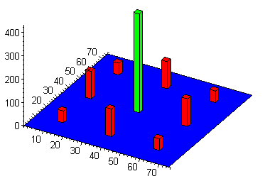

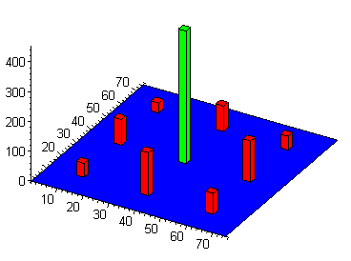

Four diodes Σ Collected charge
hit 1,2,3

1
2
3

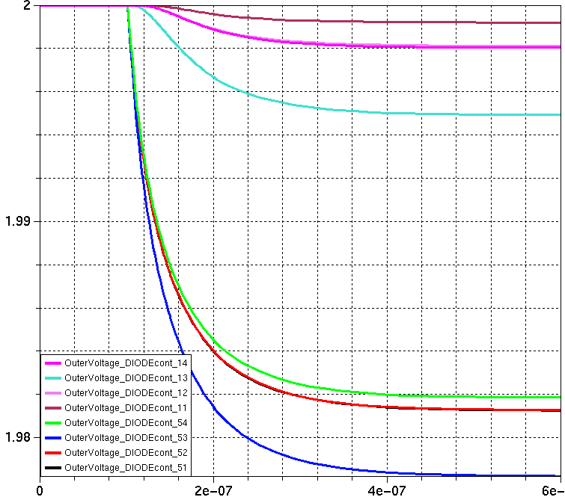
ΔV diodes hit 1: max τ_{f} ≈ 190 ns

Because of the thicker epitaxial layer, the collection time is considerably longer ( about 190 ns in case of hit 1). Worst scenario still under investigation.
Data results

*Q_xy indicates diode y of cell x ( x = 1.. 9, y = 1 .. 4)
**Charge in e⁻

Hit 1:
Epi_thickness: 20
Xhit: 37.5 Yhit: 37.5
Q_11: 4.1561336 Q_12: 10.035213 Q_13: 26.256369 Q_14: 10.07058
Q_21: 14.725188 Q_22: 14.77651 Q_23: 44.280407 Q_24: 44.014107
Q_31: 10.0325 Q_32: 4.2473917 Q_33: 10.112346 Q_34: 25.510986 Q_41: 14.988318 Q_42: 44.17688 Q_43: 43.826101 Q_44: 14.742579
Q_51: 105.32057 Q_52: 105.6373 Q_53: 105.85034 Q_54: 105.24476 Q_61: 44.31438931 Q_62: 15.144635 Q_63: 14.970992 Q_64: 43.451112
Q_71: 9.9154917 Q_72: 25.587026 Q_73: 10.168891 Q_74: 4.2477759
Q_81: 43.222846 Q_82: 42.429359 Q_83: 15.151659 Q_84: 15.132793
Q_91: 25.1917 Q_92: 9.9580095 Q_93: 4.3133659 Q_94: 10.017707

Hit 2:
Epi_thickness: 20
Xhit: 37.5 Yhit: 33.334
Q_11: 5.0008175 Q_12: 12.422484 Q_13: 31.255853 Q_14: 11.220372
Q_21: 19.378411 Q_22: 19.201943 Q_23: 57.151378 Q_24: 57.266373
Q_31: 12.2433 Q_32: 5.0240278 Q_33: 11.4022 Q_34: 30.487282 Q_41: 15.518887 Q_42: 46.831202 Q_43: 38.647709 Q_44: 13.708796
Q_51: 131.8263 Q_52: 129.25471 Q_53: 74.175268 Q_54: 81.439716
Q_61: 46.765421 Q_62: 15.023856 Q_63: 13.239372 Q_64: 37.661959
Q_71: 8.5421992 Q_72: 21.508543 Q_73: 7.8067743 Q_74: 3.4546743
Q_81: 33.480351 Q_82: 33.745346 Q_83: 11.314776 Q_84: 11.285515
Q_91: 21.242024 Q_92: 8.6246681 Q_93: 3.3682206 Q_94: 7.6818034

Hit 3:
Epi_thickness: 20
Xhit: 41.666 Yhit: 33.334
Q_11: 3.9712506 Q_12: 10.330145 Q_13: 23.605854 Q_14: 8.2681551
Q_21: 17.498337 Q_22: 19.736355 Q_23: 59.692899 Q_24: 47.636232
Q_31: 14.215433 Q_32: 5.5522671 Q_33: 13.929109 Q_34: 36.60602 Q_41: 11.360046 Q_42: 34.695595 Q_43: 29.371978 Q_44: 10.176954
Q_51: 89.561586 Q_52: 205.37609 Q_53: 86.355014 Q_54: 63.587207
Q_61: 60.121121 Q_62: 19.399156 Q_63: 15.463794 Q_64: 42.814705
Q_71: 6.4836427 Q_72: 17.021091 Q_73: 6.8909358 Q_74: 2.80694
Q_81: 28.966561 Q_82: 34.430412 Q_83: 11.74703 Q_84: 10.545382
Q_91: 23.600926 Q_92: 9.9148138 Q_93: 3.9960302 Q_94: 8.7575155

Hit 4:
Epi_thickness: 20
Xhit: 37.5 Yhit: 29.168
Q_11: 5.7463732 Q_12: 14.799092 Q_13: 34.86106 Q_14: 12.209438
Q_21: 25.395439 Q_22: 23.438979 Q_23: 77.890035 Q_24: 73.966794
Q_31: 15.124421 Q_32: 6.0464558 Q_33: 12.5505 Q_34: 36.36757 Q_41: 15.23474 Q_42: 45.87287 Q_43: 31.91447 Q_44: 11.955502
Q_51: 128.78714 Q_52: 130.29091 Q_53: 54.668731 Q_54: 58.740619
Q_61: 44.993341 Q_62: 14.157227 Q_63: 10.917222 Q_64: 31.467531
Q_71: 6.9559999 Q_72: 16.407476 Q_73: 6.1282684 Q_74: 2.8369648
Q_81: 24.702122 Q_82: 26.043483 Q_83: 9.1139097 Q_84: 8.657797
Q_91: 16.876641 Q_92: 7.1836579 Q_93: 2.8759572 Q_94: 6.4861081

Hit 5:
Epi_thickness: 20
Xhit: 41.666 Yhit: 29.168
Q_11: 4.5444312 Q_12: 12.140449 Q_13: 26.860258 Q_14: 9.2660189
Q_21: 22.937298 Q_22: 25.904175 Q_23: 83.199287 Q_24: 60.665848
Q_31: 22.3181 Q_32: 7.2603518 Q_33: 15.508076 Q_34: 44.292456 Q_41: 11.24143 Q_42: 34.413472 Q_43: 25.488914 Q_44: 9.2837691
Q_51: 89.626951 Q_52: 200.01157 Q_53: 58.563052 Q_54: 50.053989
Q_61: 58.101713 Q_62: 19.233053 Q_63: 14.525009 Q_64: 38.648536
Q_71: 5.6810545 Q_72: 13.874428 Q_73: 5.3760143 Q_74: 2.3800536
Q_81: 22.440591 Q_82: 25.652958 Q_83: 8.850388 Q_84: 8.0011586
Q_91: 18.345212 Q_92: 8.0551717 Q_93: 3.2635223 Q_94: 6.7596552

Hit 6:
Epi_thickness: 20
Xhit: 45.832 Yhit: 29.168
Q_11: 3.487069 Q_12: 9.6213286 Q_13: 20.234617 Q_14: 6.7907139
Q_21: 19.439397 Q_22: 24.856202 Q_23: 82.908642 Q_24: 46.665798
Q_31: 21.138971 Q_32: 8.4628483 Q_33: 21.329193 Q_34: 57.342362 Q_41: 8.3881817 Q_42: 25.573064 Q_43: 19.852255 Q_44: 7.0805533
Q_51: 63.023037 Q_52: 195.3334 Q_53: 58.247776 Q_54: 40.711293
Q_61: 82.91456 Q_62: 27.345465 Q_63: 19.516738 Q_64: 47.112819
Q_71: 4.3955222 Q_72: 11.417123 Q_73: 4.5579283 Q_74: 1.9389947
Q_81: 19.802277 Q_82: 25.409827 Q_83: 8.8576482 Q_84: 7.2297542
Q_91: 20.359546 Q_92: 9.6411655 Q_93: 3.5725369 Q_94: 7.2528675

Hit 7:
Epi_thickness: 20
Xhit: 37.5 Yhit: 25.002
Q_11: 6.8635327 Q_12: 17.847283 Q_13: 40.120314 Q_14: 13.037796
Q_21: 30.196423 Q_22: 31.677948 Q_23: 99.583952 Q_24: 100.21872
Q_31: 17.33658 Q_32: 6.5954795 Q_33: 13.396282 Q_34: 40.024515 Q_41: 14.211989 Q_42: 42.476131 Q_43: 26.972767 Q_44: 10.419315
Q_51: 106.58965 Q_52: 102.76357 Q_53: 44.94982 Q_54: 45.147849
Q_61: 42.01546 Q_62: 14.501877 Q_63: 9.576392 Q_64: 26.597268
Q_71: 5.7873346 Q_72: 13.147791 Q_73: 4.8301693 Q_74: 2.3313911
Q_81: 18.834062 Q_82: 19.198186 Q_83: 6.7610921 Q_84: 6.6735362
Q_91: 12.962306 Q_92: 5.7163733 Q_93: 2.2087398 Q_94: 4.8106082

Hit 8:
Epi_thickness: 20
Xhit: 41.666 Yhit: 25.002
Q_11: 5.1569138 Q_12: 13.680689 Q_13: 29.74458 Q_14: 9.5877216
Q_21: 28.515976 Q_22: 33.679312 Q_23: 123.47548 Q_24: 75.152906
Q_31: 28.33547 Q_32: 7.8187197 Q_33: 17.422892 Q_34: 52.399294 Q_41: 10.805035 Q_42: 33.056371 Q_43: 21.882462 Q_44: 8.1590407
Q_51: 80.40638 Q_52: 130.76035 Q_53: 44.824215 Q_54: 39.829329
Q_61: 52.087954 Q_62: 18.722046 Q_63: 12.338392 Q_64: 28.756646
Q_71: 4.6277018 Q_72: 11.397052 Q_73: 4.3303009 Q_74: 1.9364836
Q_81: 17.70669 Q_82: 19.908142 Q_83: 7.0151809 Q_84: 6.2959391
Q_91: 14.675915 Q_92: 6.6372904 Q_93: 2.5881291 Q_94: 5.3712306

Hit 9:
Epi_thickness: 20
Xhit: 45.832 Yhit: 25.002
Q_11: 5.4715306 Q_12: 7.532557 Q_13: 17.143292 Q_14: 7.213349
Q_21: 28.23121 Q_22: 33.75362 Q_23: 122.5678 Q_24: 53.53494
Q_31: 27.77913 Q_32: 13.38358 Q_33: 28.46328 Q_34: 76.57895 Q_41: 7.5781853 Q_42: 17.6363 Q_43: 7.421577 Q_44: 5.174566
Q_51: 53.49671 Q_52: 123.7518 Q_53: 33.79314 Q_54: 28.7132
Q_61: 75.13561 Q_62: 30.0718 Q_63: 14.1839 Q_64: 28.565211
Q_71: 3.27757 Q_72: 6.135782 Q_73: 7.2135679 Q_74: 2.6353276
Q_81: 14.573235 Q_82: 19.842641 Q_83: 7.111350 Q_84: 5.17466
Q_91: 17.701639 Q_92: 11.391331 Q_93: 4.83567 Q_94: 6.735219

Hit 10:
Epi_thickness: 20
Xhit: 49.998 Yhit: 25.002
Q_11: 2.8570755 Q_12: 8.7371389 Q_13: 16.857809 Q_14: 5.5485515
Q_21: 19.444885 Q_22: 32.6929 Q_23: 101.08573 Q_24: 41.205841
Q_31: 40.215488 Q_32: 13.956532 Q_33: 29.927686 Q_34: 96.979019 Q_41: 6.2996658 Q_42: 18.701626 Q_43: 14.053555 Q_44: 5.0782573
Q_51: 44.262149 Q_52: 105.28077 Q_53: 43.621669 Q_54: 28.192685
Q_61: 96.745231 Q_62: 29.516106 Q_63: 17.20022 Q_64: 40.177552
Q_71: 3.3037016 Q_72: 8.1013368 Q_73: 3.183373 Q_74: 1.3576457
Q_81: 14.075206 Q_82: 18.804658 Q_83: 6.0014489 Q_84: 5.1186729
Q_91: 16.952924 Q_92: 8.1820248 Q_93: 2.9972539 Q_94: 5.7481085

Next step would be to characterize the spread of charge to neighboring diodes from the data above, to asses if such a combination (i.e. S4 diodes layout and 20 μm epitaxial thickness) is satisfactory.

⁯

